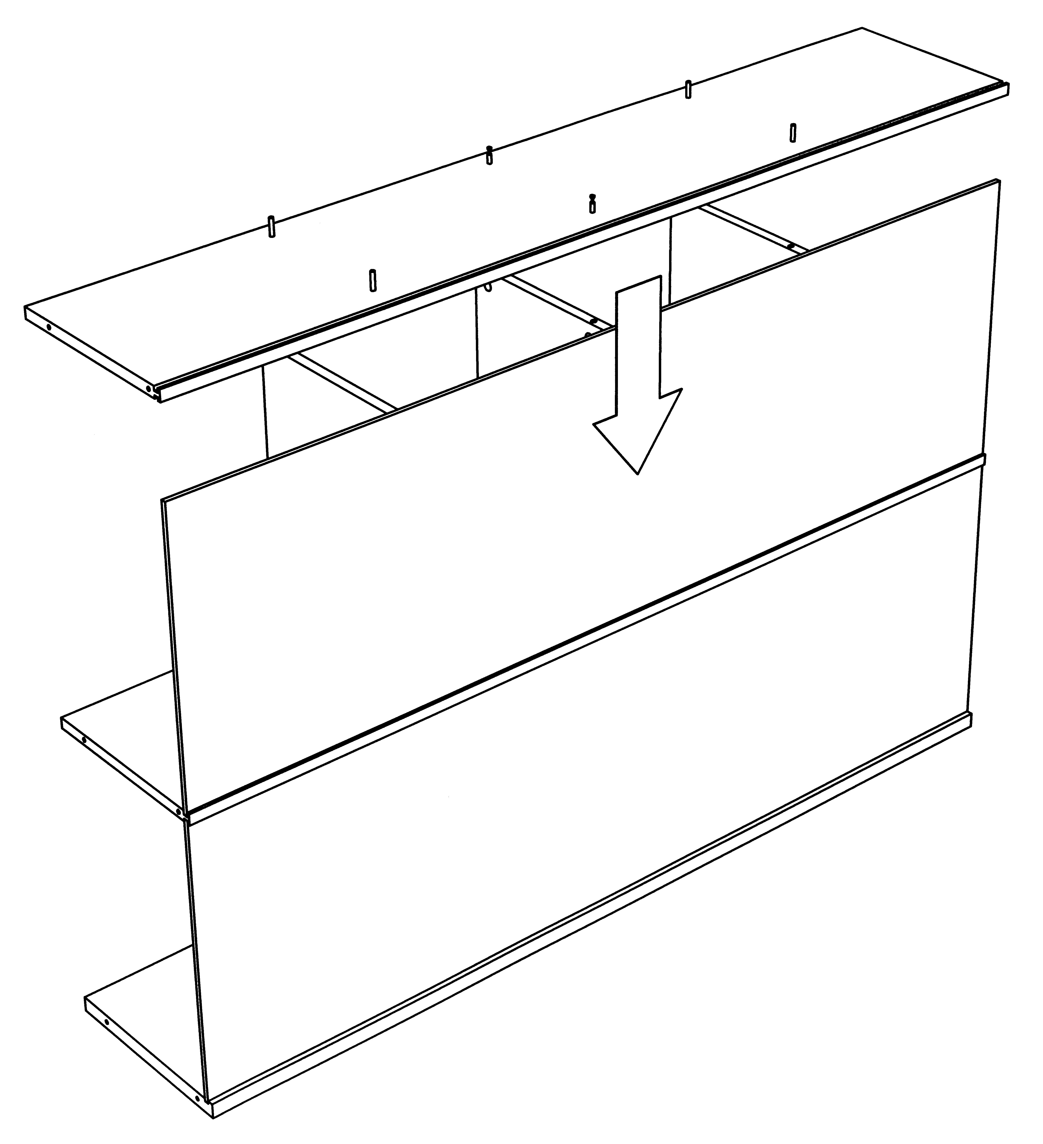
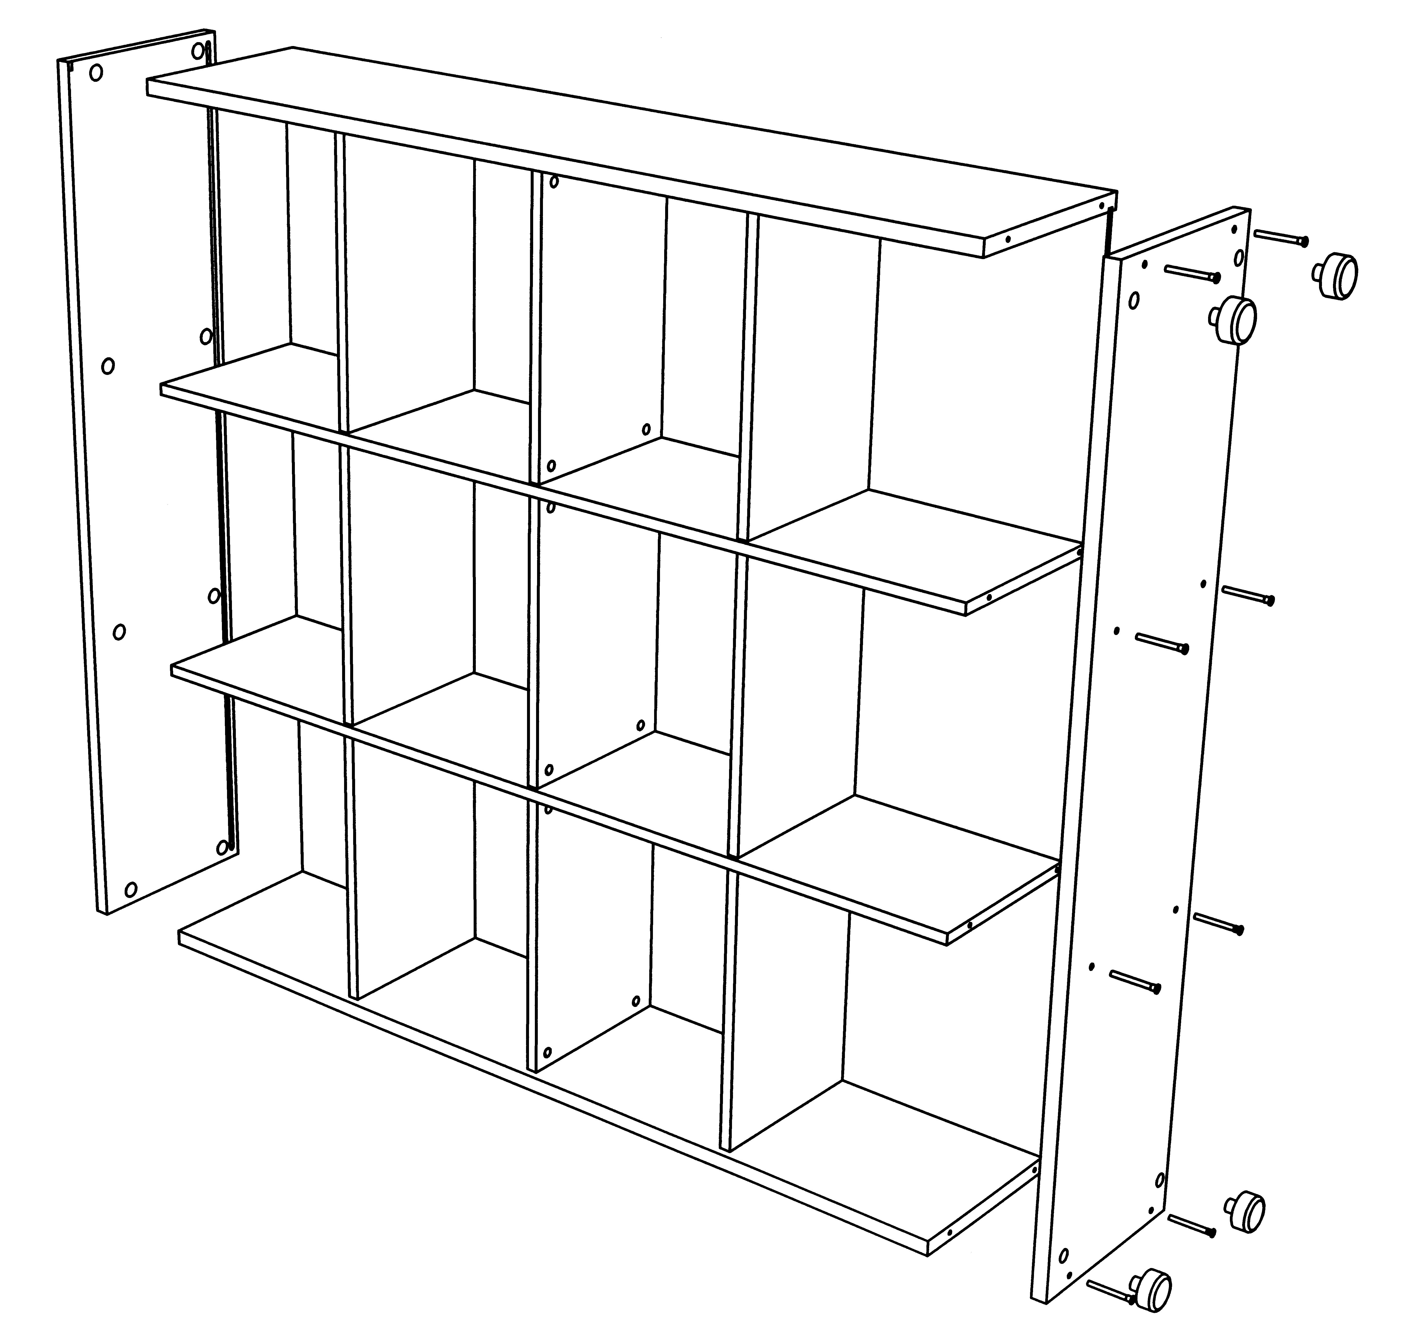
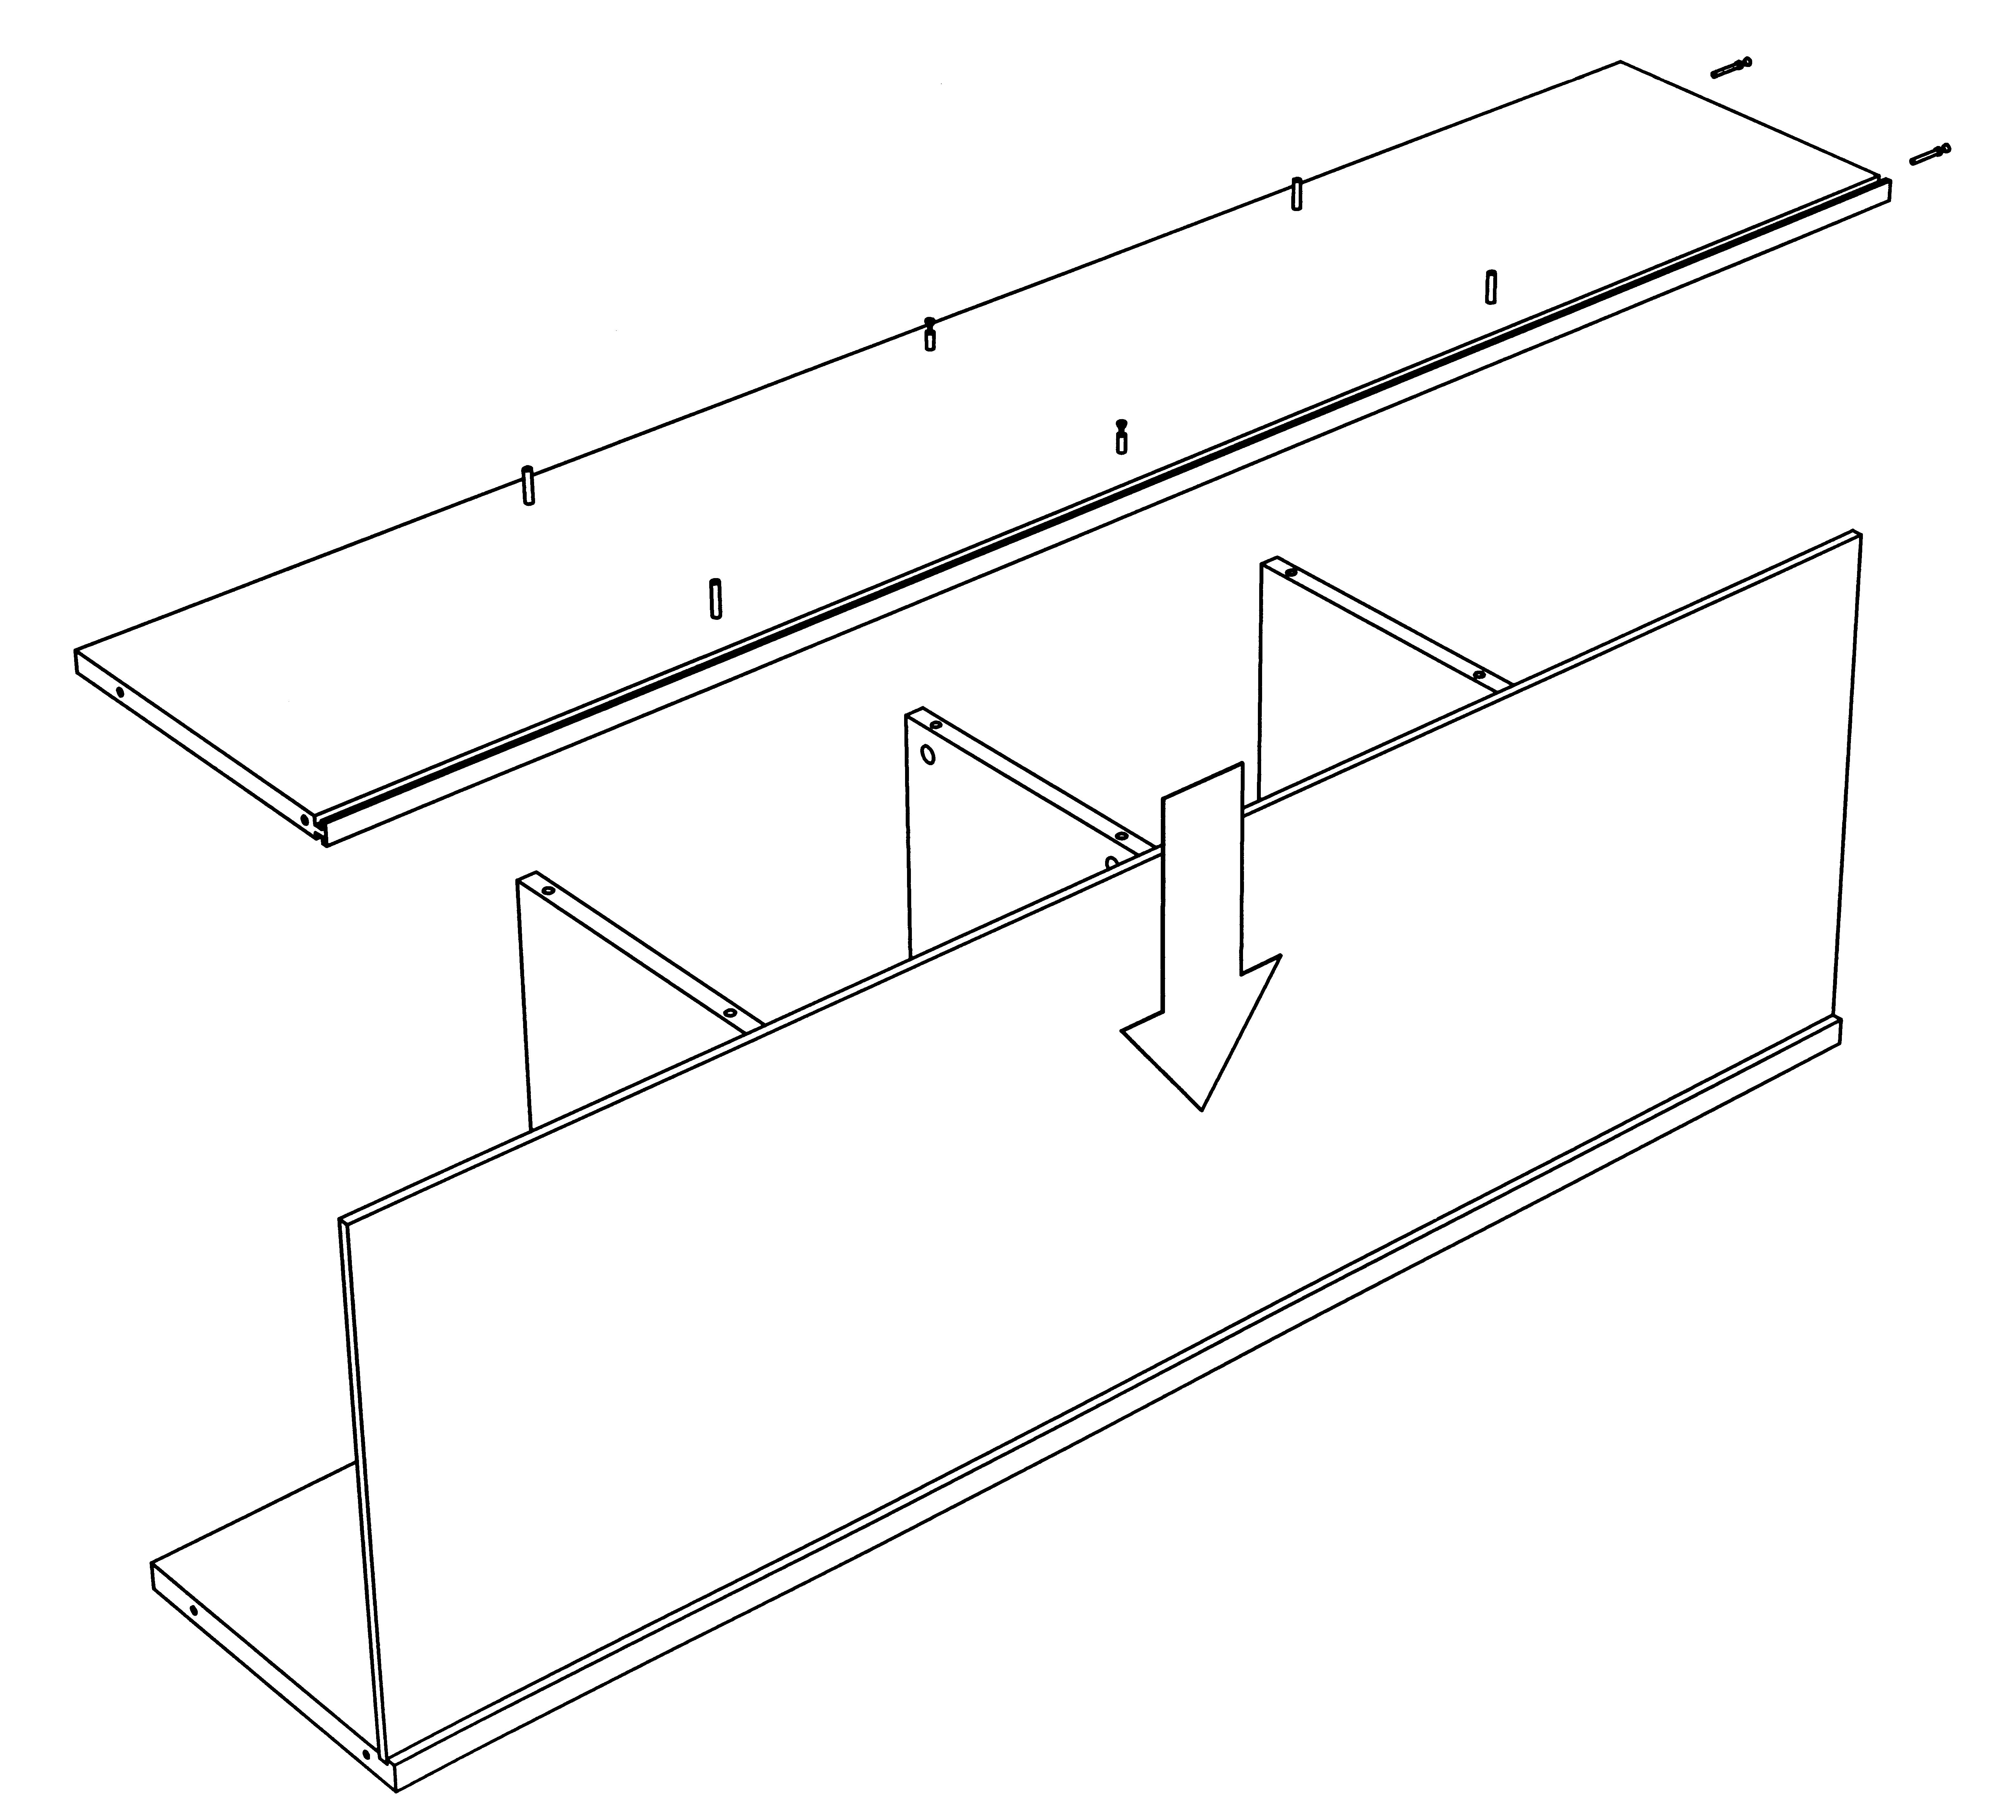
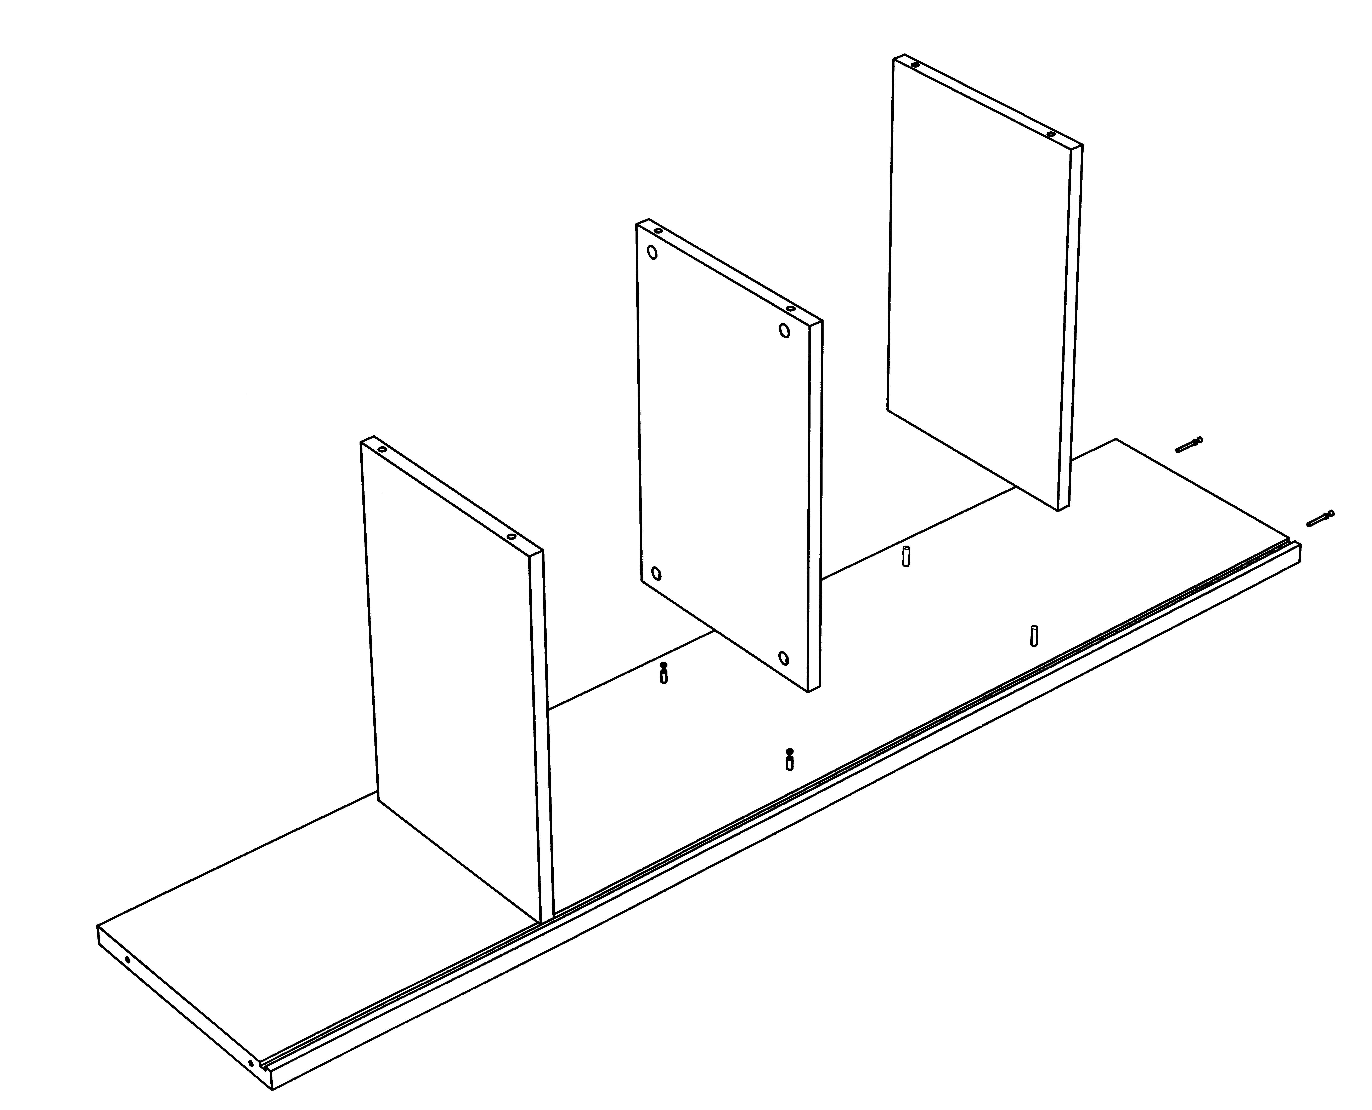

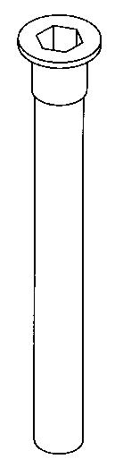
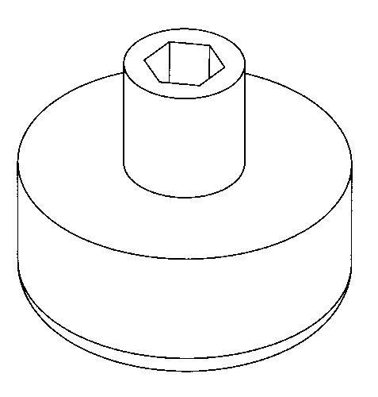
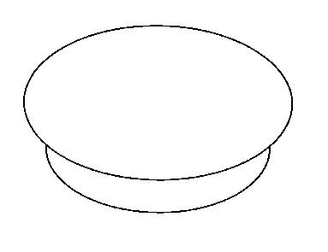
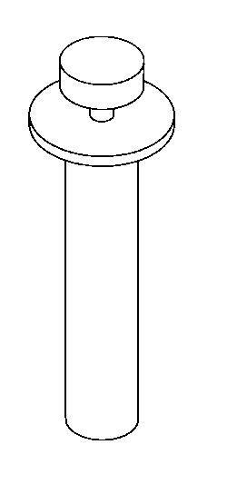
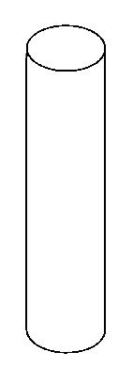

X 8. A
X 4. B
X 4. C
X 8. D
X 24. E
X 12. F
FITTINGS

Intuition 1500 open bookcase unit assembly instructions. IBU1516
STEP 1.

- Lay 1 end panel on its side as per diagram right.
- Insert 2 x metal dowels (F) into end panel for the middle shelves.
- Insert 24 wooden dowels (E) into end, top and bottom.
- Insert 2 long metal dowels (D) into top edge of all 4 vertical panels. Top edge determined by veneer crowns.
- Drop shelves onto dowels, middle shelf has metal cams. Make sure veneered edge of shelf faces front of unit.
- Tighten cams on middle shelf.
STEP 4.
- Align bottom panel with bottom of unit.
- Make sure back panels fit into groove in bottom.
- Fix bottom to vertical panels using 8 x screws (A) provided.
- Align KD fittings in top with metal dowels (D) in vertical panels.
- Push top to fit flush. Make sure back panels fit into groove in top.
- Using a pozi screw driver tighten each KD fitting in top.
- Push plastic feet (B) into holes in bottom and cover caps (C) on inside of bottom.
- Rotate cabinet into correct position.
STEP 2.
- Drop back panel into groove in end panel.
- Insert wooden and metal dowels (D, E&F) into divider panel (both sides and end) as step 1.
- Drop divider panel onto shelves aligning dowels with holes in shelves and back panel into groove.
- Tighten cams in middle shelf.
STEP 3.
- Continue building cabinet as described in steps 1 and 2, use remaining divider panel then end panel to finish.
- Tighten cams on each middle shelf as you go.
17/4/2002. SHEET 7
4 x cams

