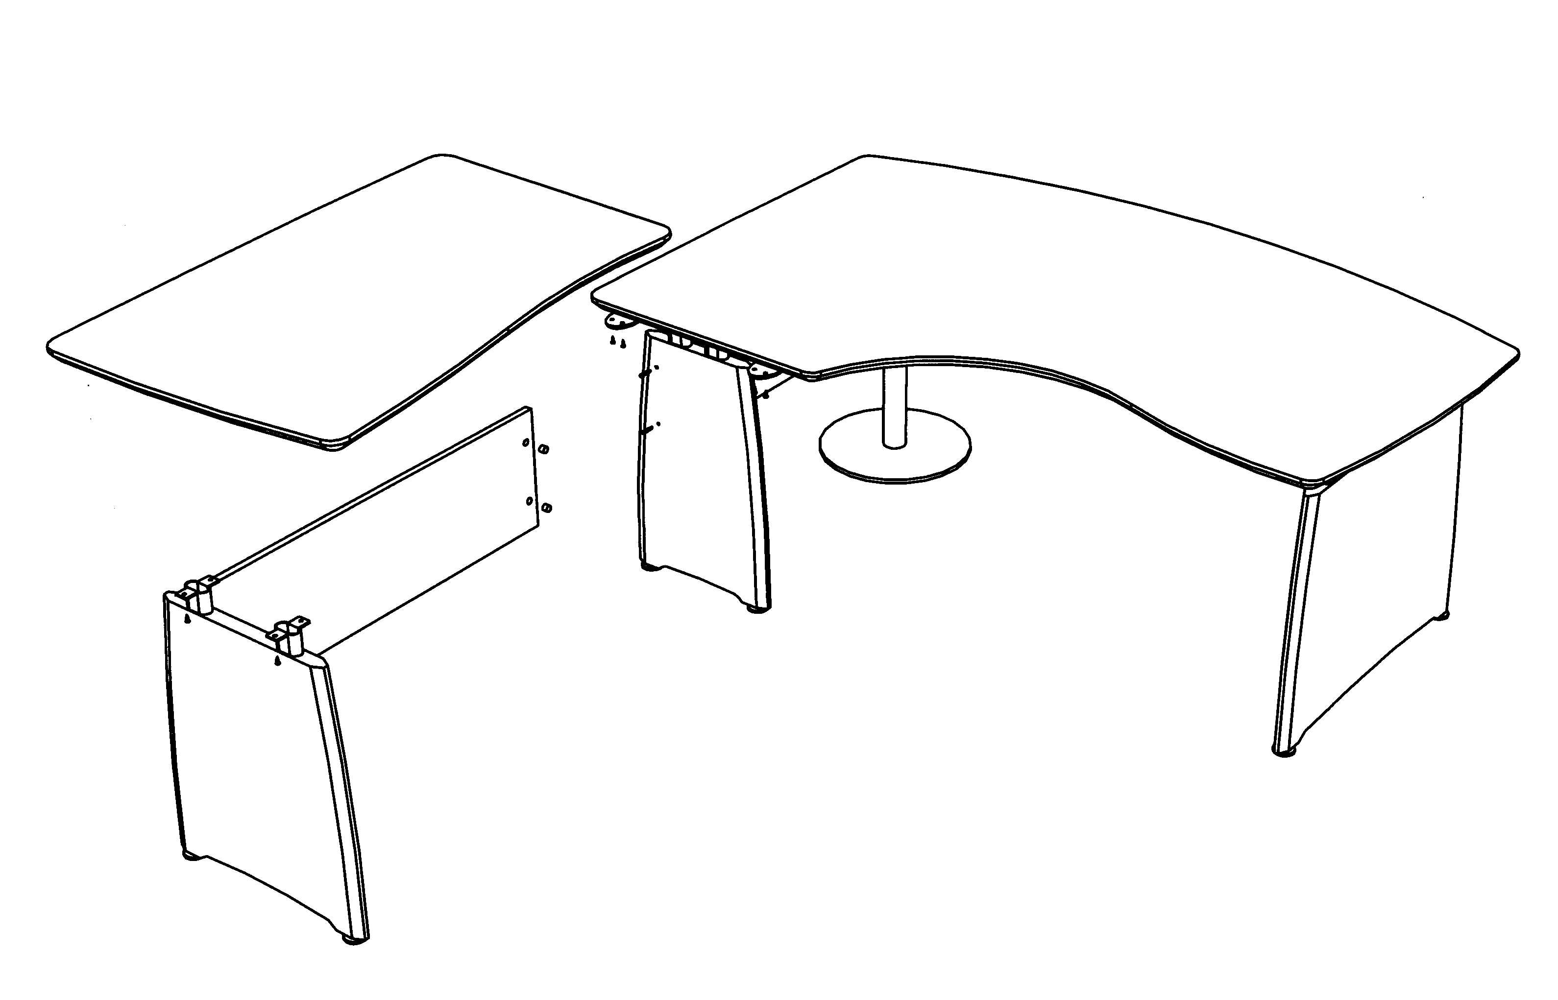
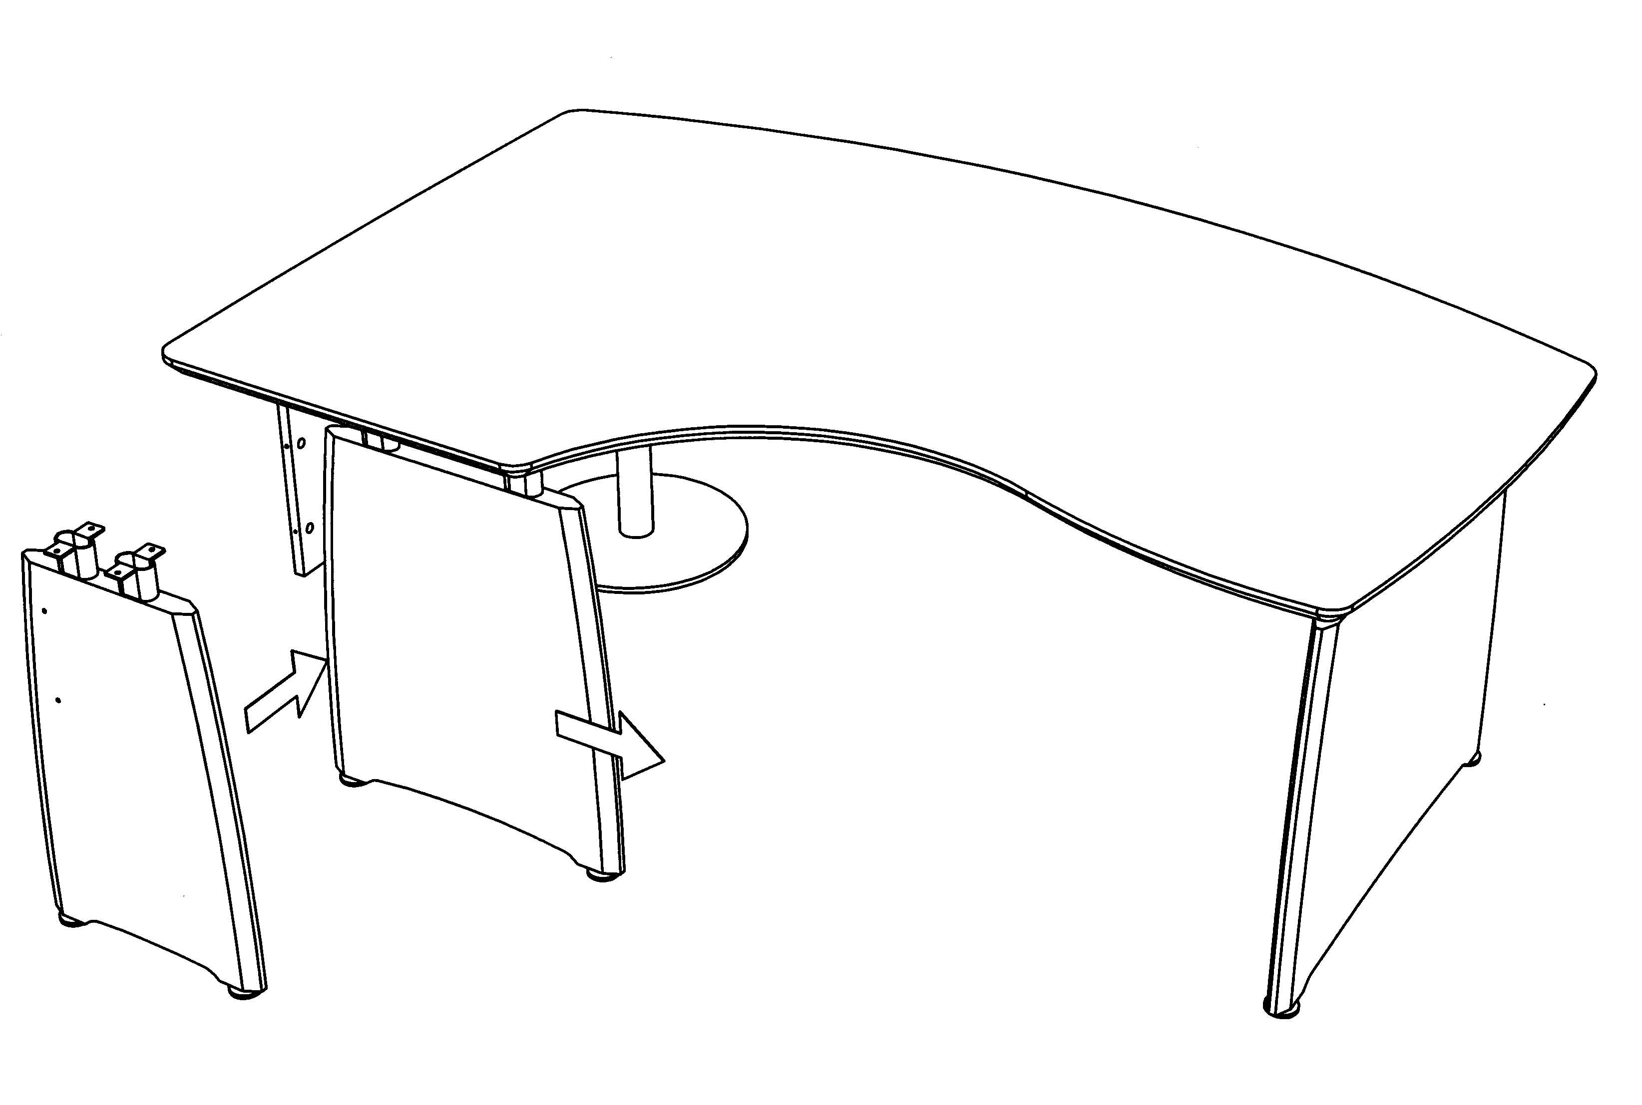
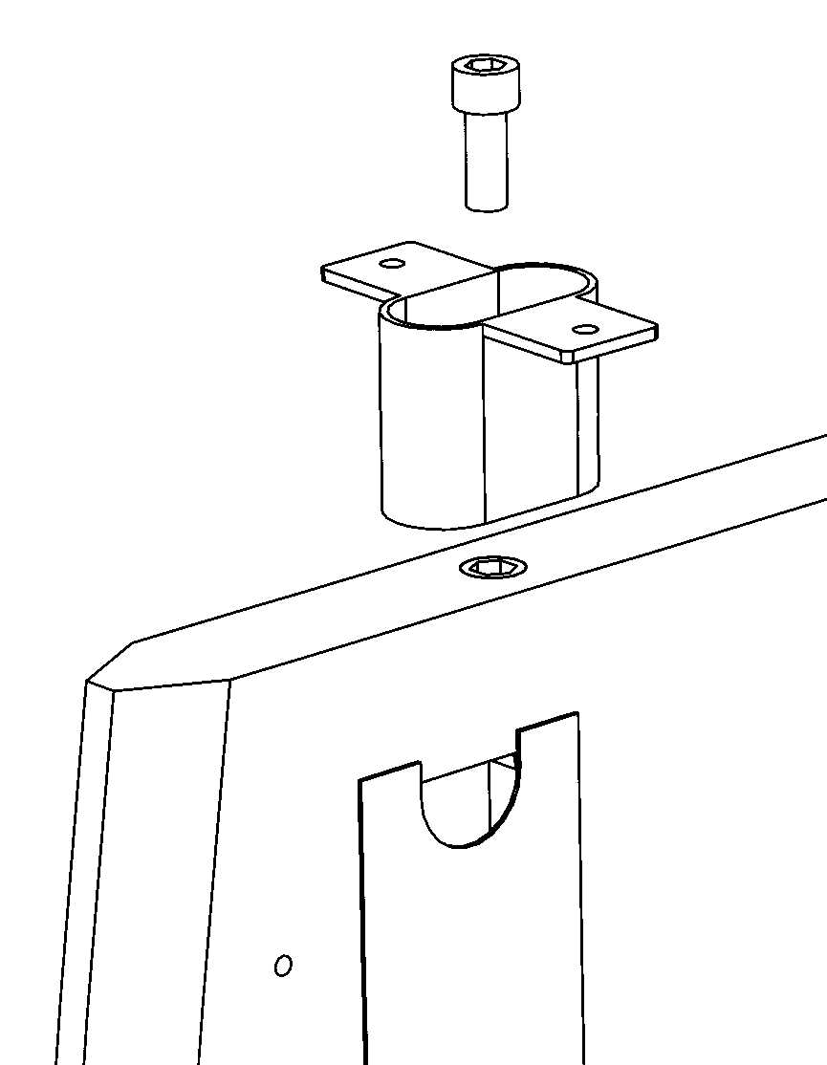

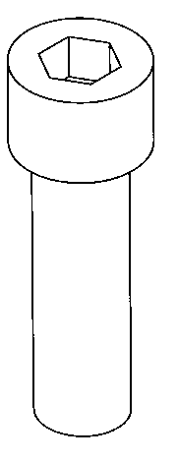
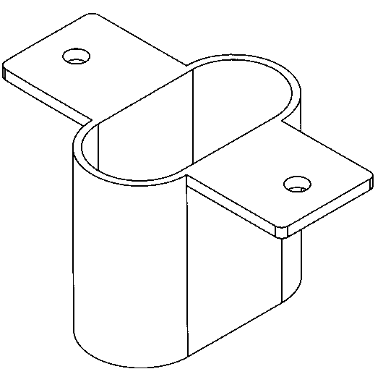
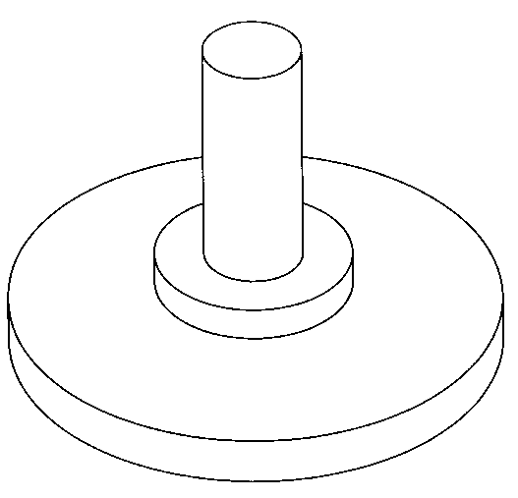
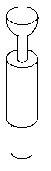
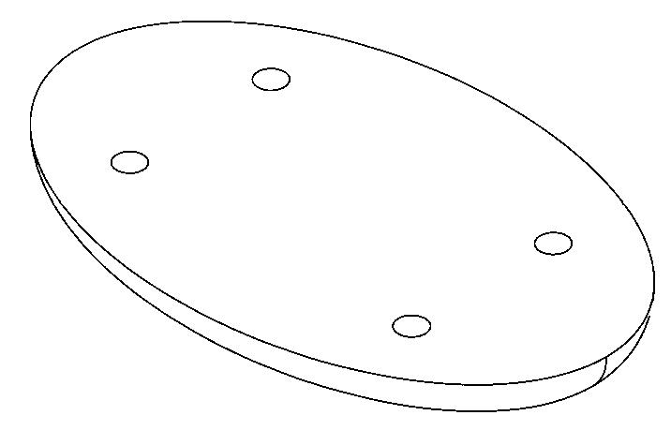
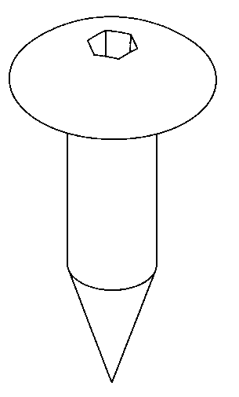
X 2

Intuition
Crescent return assembly instructions
ICRT1107/L & R
STEP 1.
Screw all metal spacers to the top of the panel ends using the M10 x 25 socket cap screws provided.
STEP 3.
- Fix linking plates to underside of desk using the mushroom headed screws provided.
- Screw cam bolts into holes in cut back panel end.
- Fit cams into holes each end of return back panel.
- Fit back panel to panel ends and
tighten cams with screwdriver to secure in position.
- Align metal spacers with holes in underside of top and fix in position using the mushroom headed screws provided.
STEP 2.
Undo cams and replace existing panel end from desk (If applicable) with cut back panel end.
1/5/2004 SHEET 3

X 2
FITTINGS

X 12

X 2

X 4

X 2

