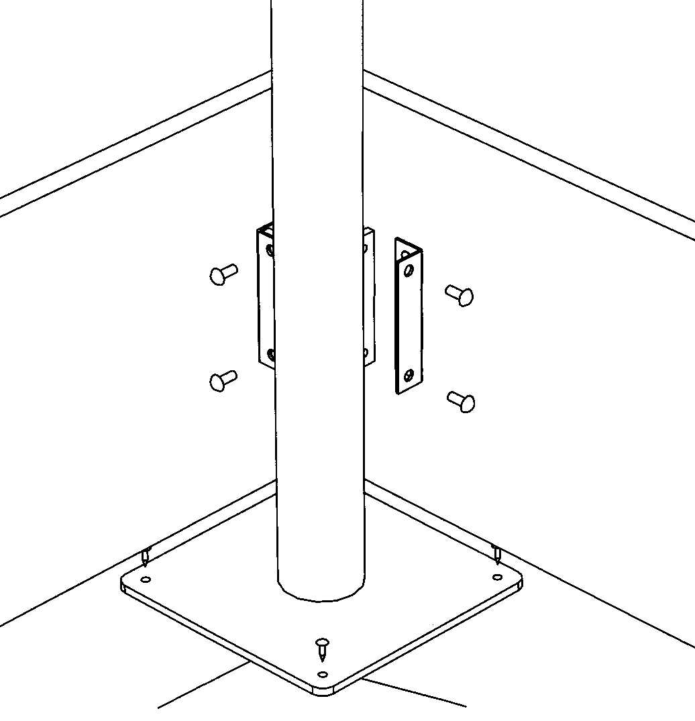
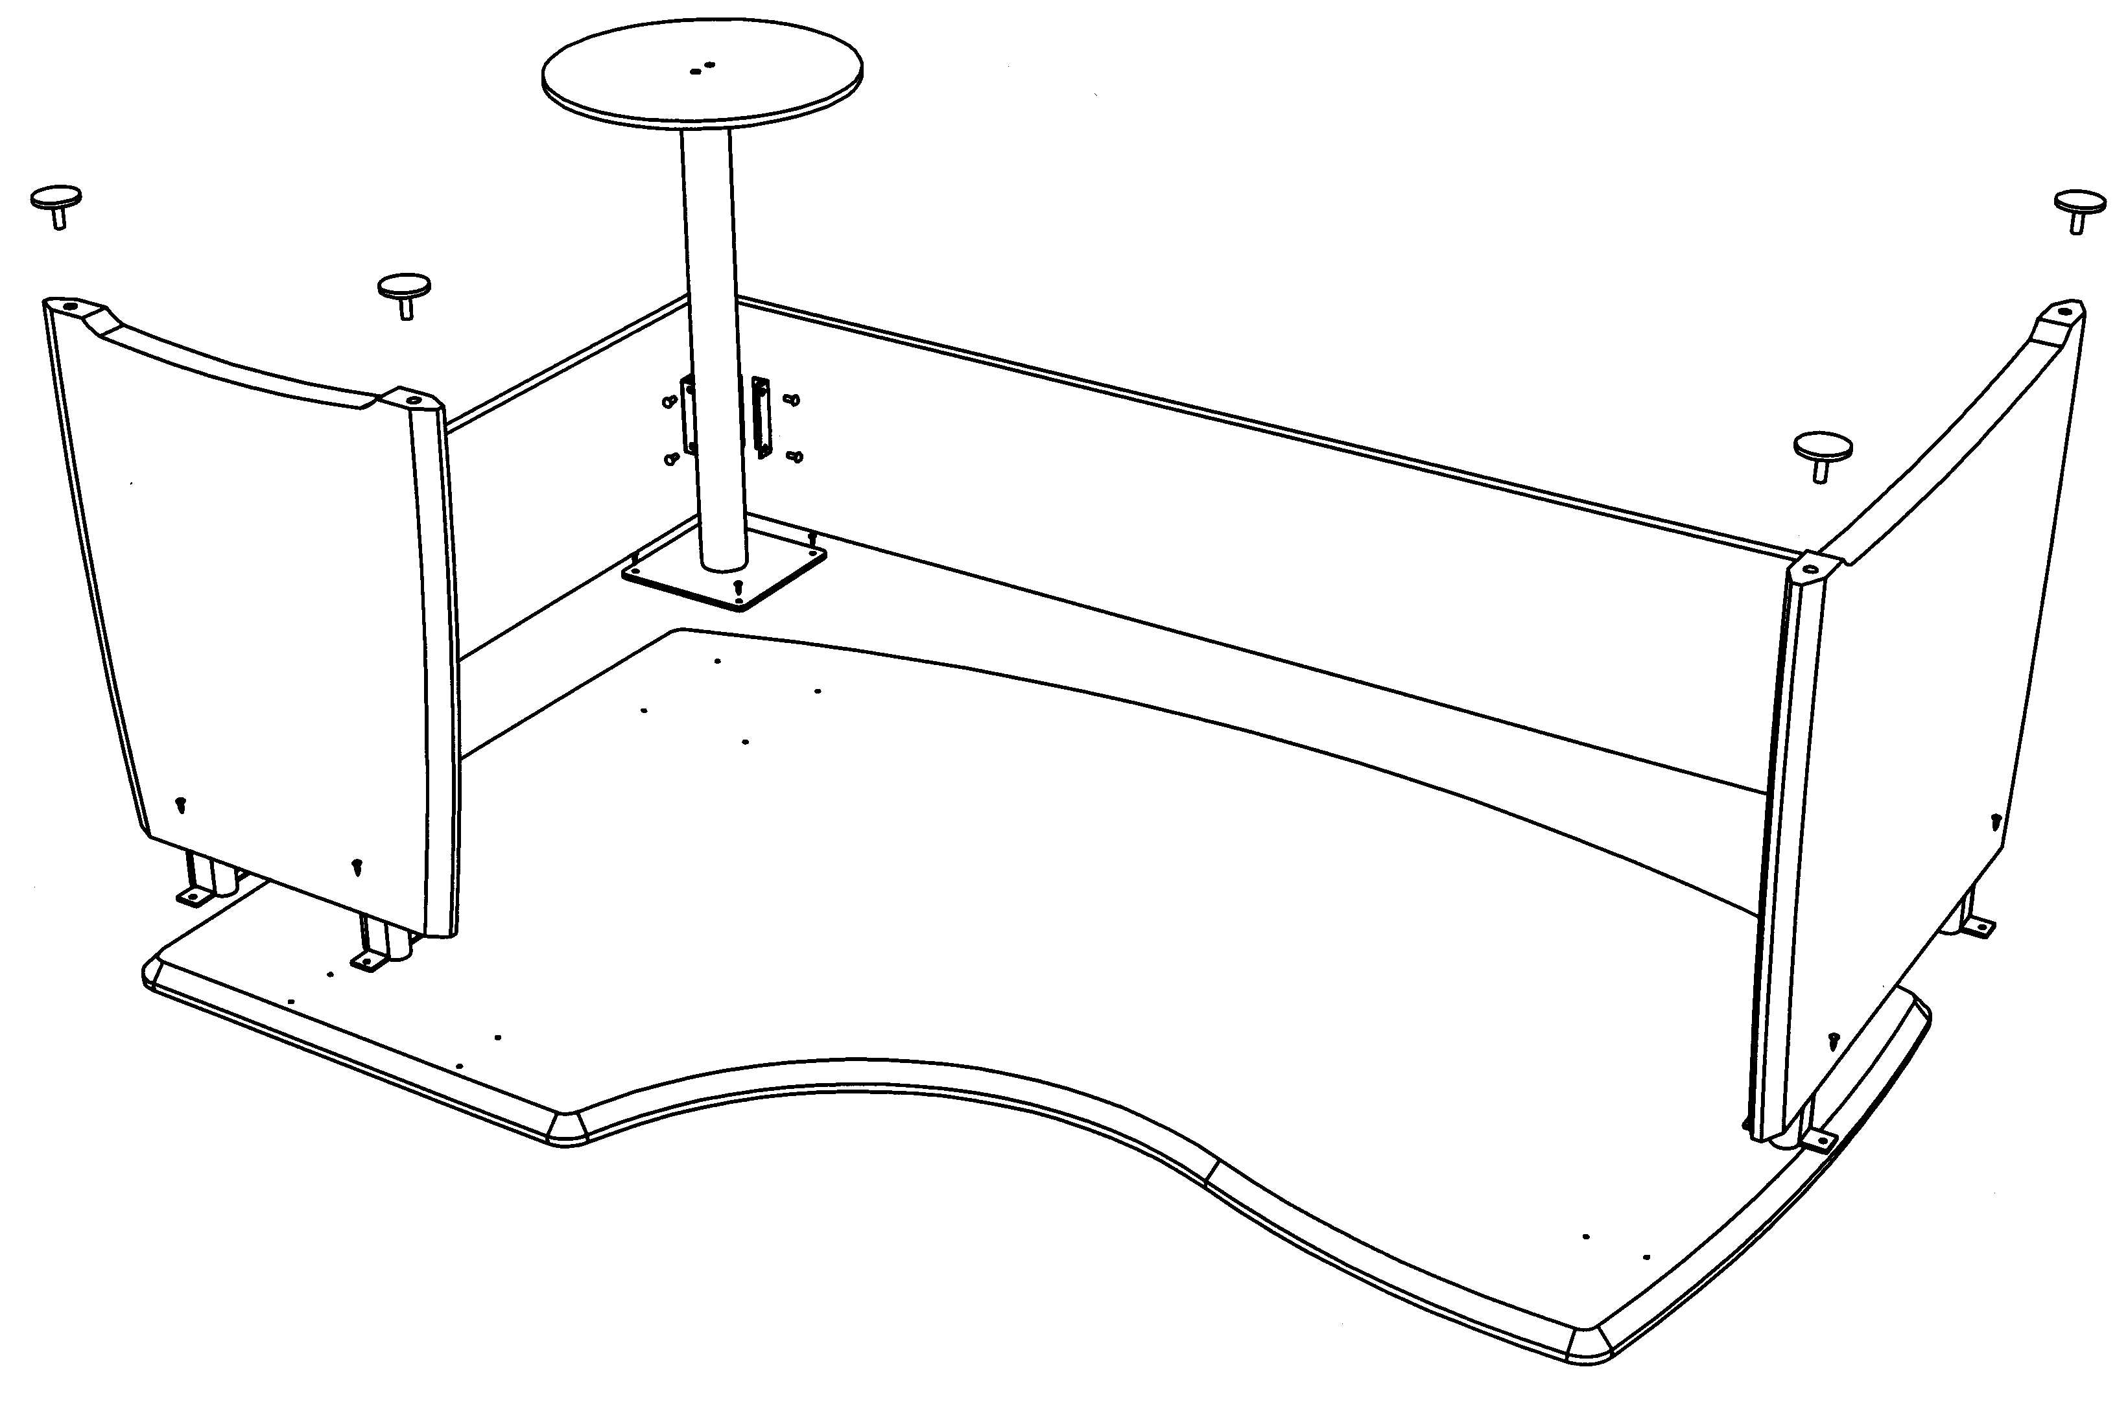
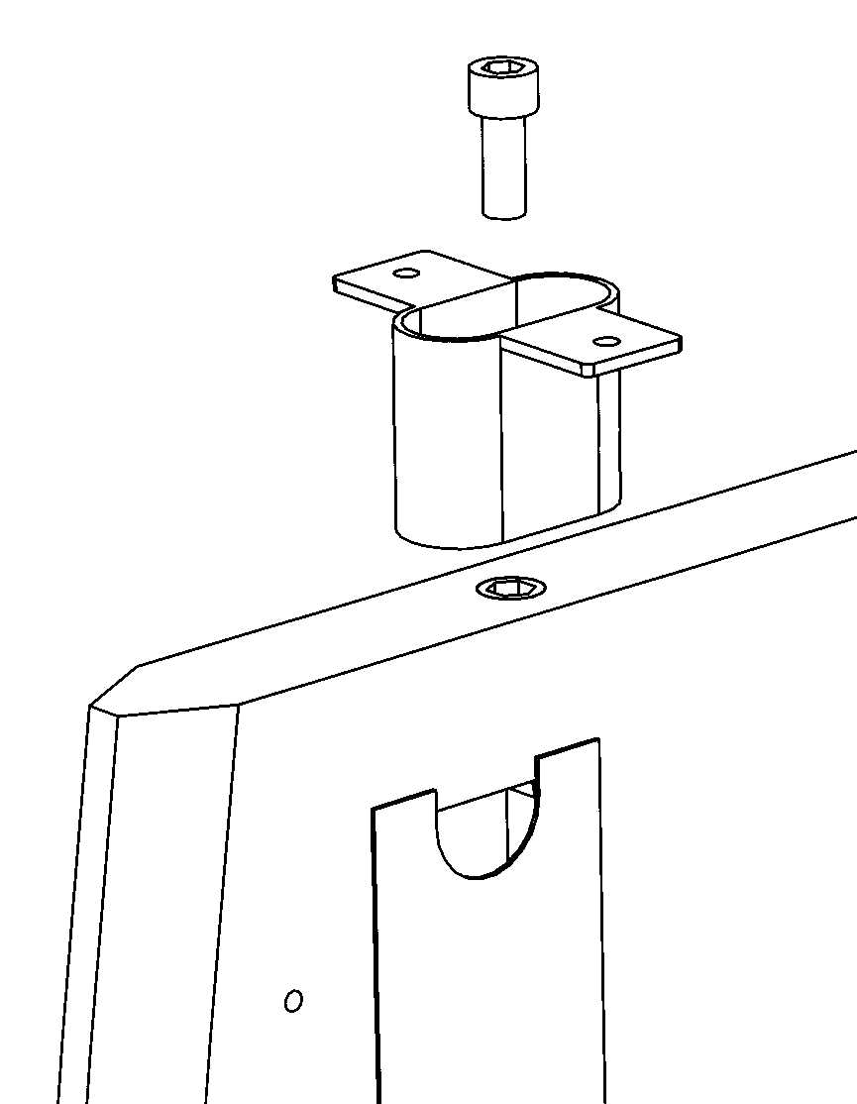
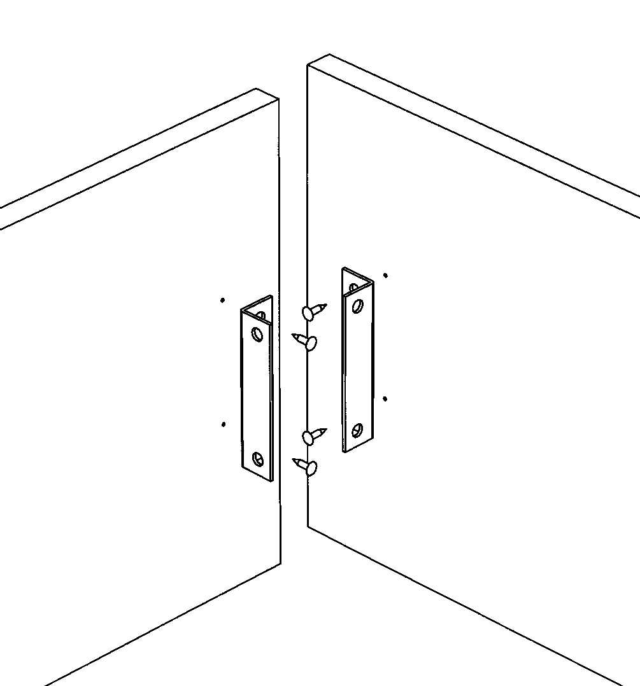

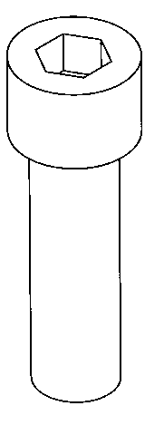
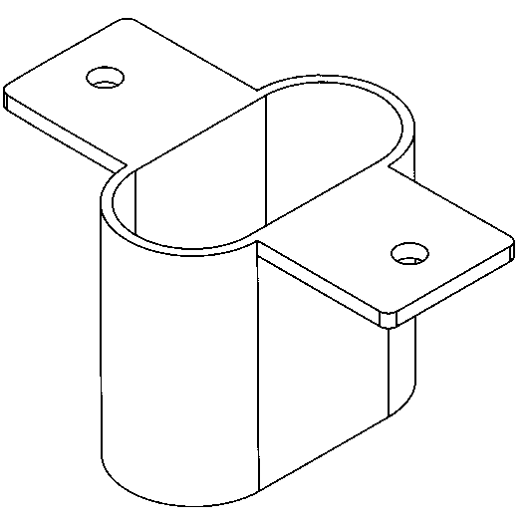
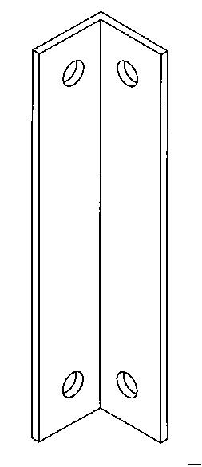
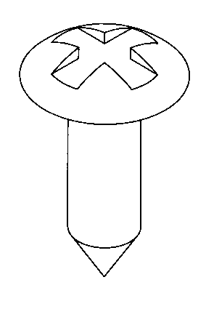
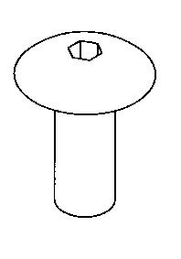
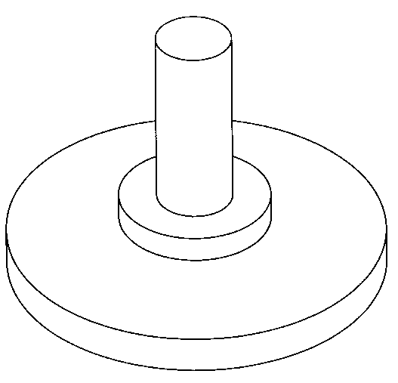

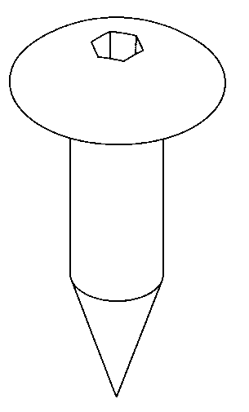
X 4
X 4

Intuition Desk assembly instructions

ICD1912 L & R
STEP 1.
Screw all metal spacers to the panel ends using the M10 x 25 socket cap screws provided.
STEP 6.
- Screw cam bolts into holes in the panel ends.
- Fit cams into holes in ends of back panels.
- Fit back panels to panel ends and tighten cams with screwdriver to secure in position.
STEP 3.
- Align back panel brackets with column leg brackets and fix together using the M6 mushroom headed screws provided.
STEP 6.
Align metal spacers with holes in underside of top and fix in position using the mushroom headed screws provided.
SPECIAL NOTE:
Fix cut back panel end here if desk has a return. (see return instruction sheet).
STEP 4.
Screw adjuster feet into inserts in bottom of panel ends.
STEP 4.
STEP 2.
- Screw two brackets
to end of back panels as per diagram left using the 5.0 x 16 flange head screws provided.

1/5/2004 SHEET 2

X 12
FITTINGS

X 4

X 4

X 2

X 4

X 4

