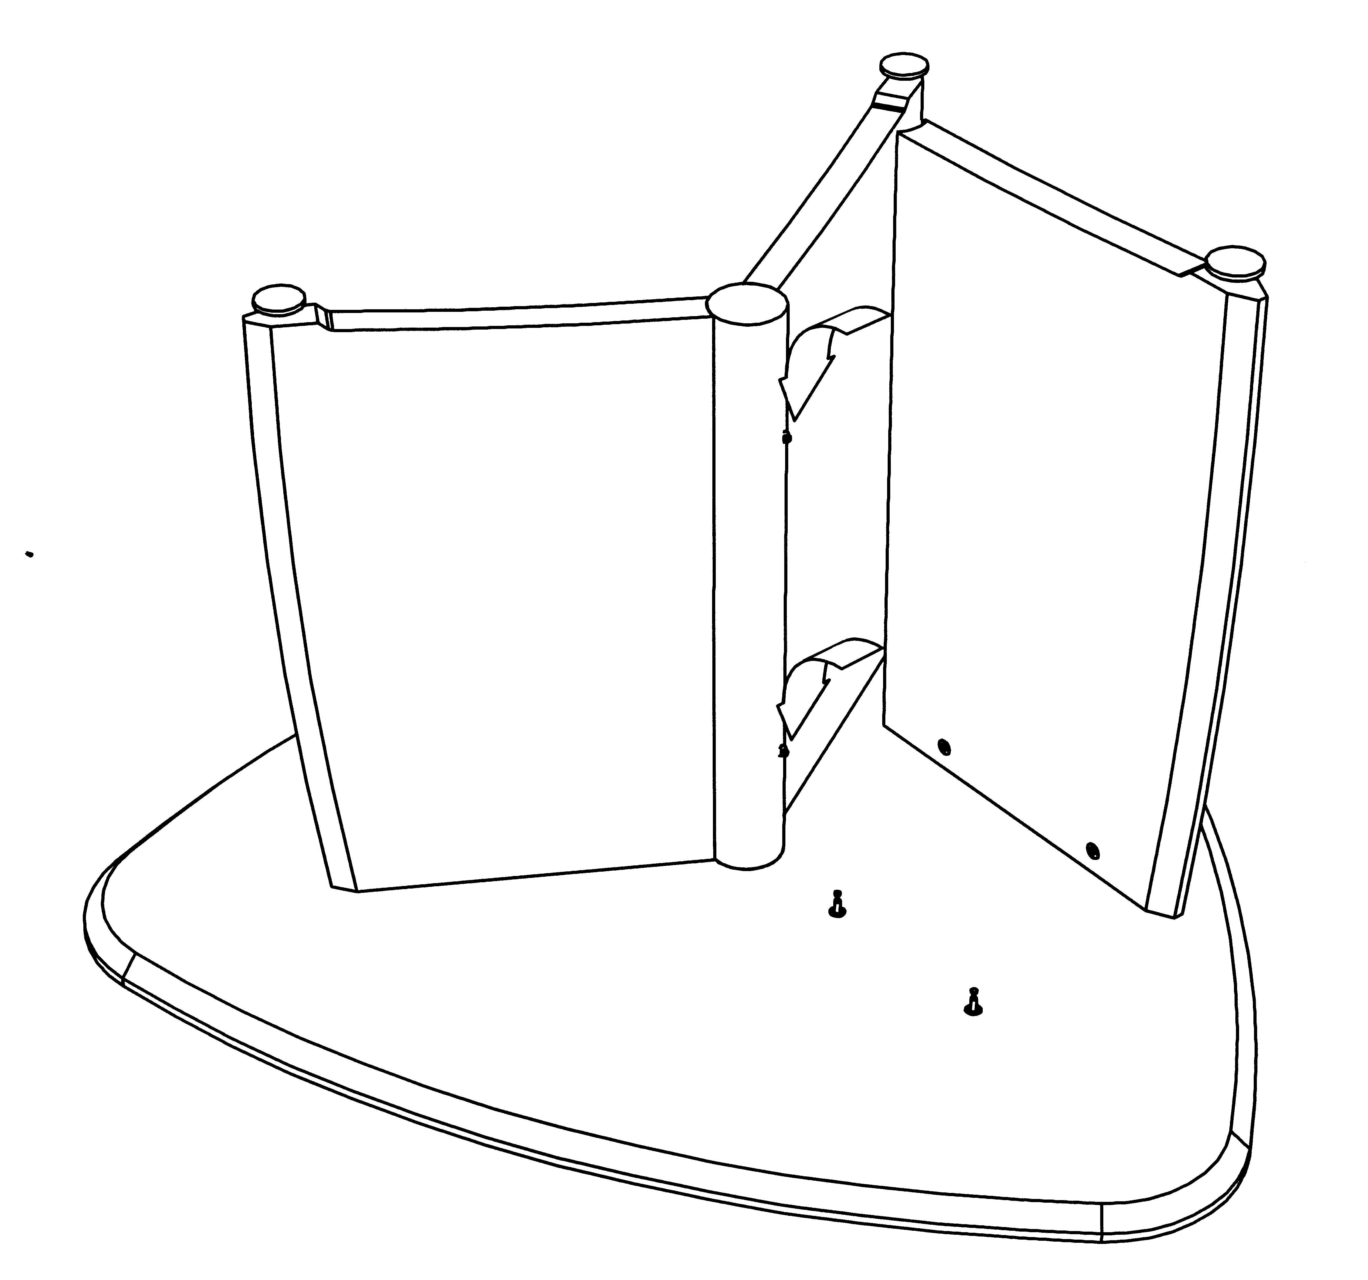
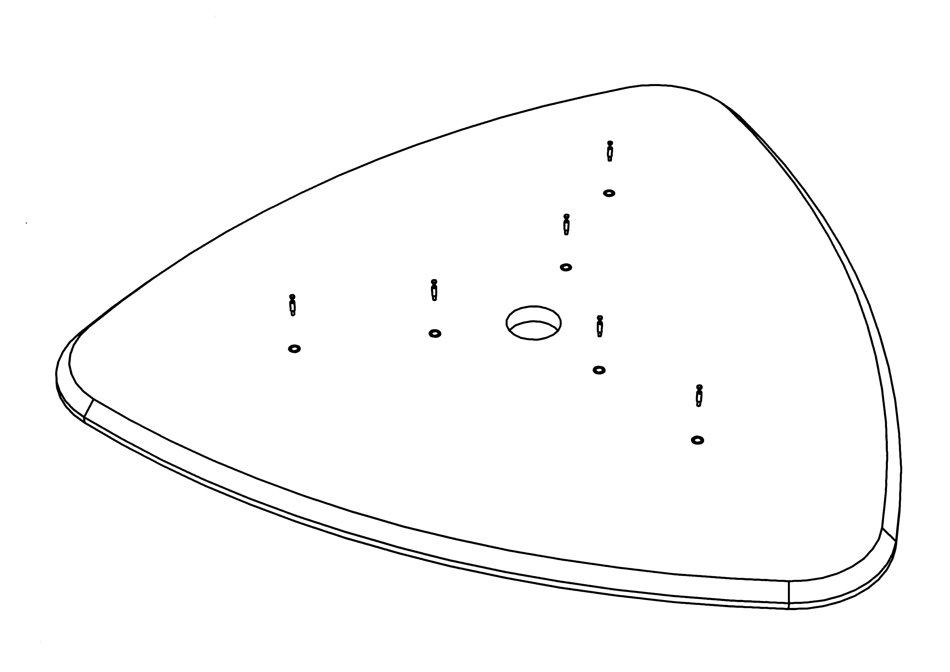

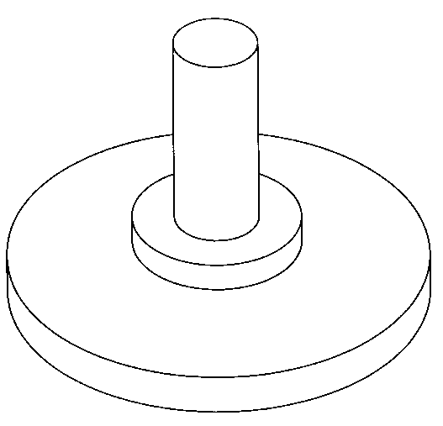

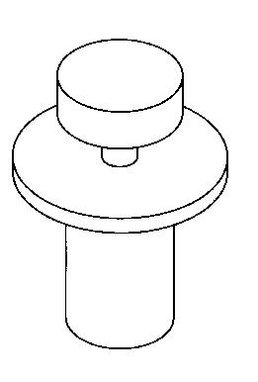

Intuition
Meeting table/coffee table assembly instructions
IMT1. IMT2. IMT 3. COF7. COF8.
STEP 1.
Screw cam bolts into inserts in underside of top.
STEP 3.
- Screw keyhole pins into
holes in metal column.
- Fit cams into holes in legs.
- Stand metal column centrally on top and fit each leg onto the keyhole pins.

STEP 5.
Align metal column and legs
with cam bolts in top and
tighten cams with screwdriver
to secure in position.

STEP 2.
Screw adjuster feet into inserts in bottom of legs.
1/5/2004 SHEET 5
FITTINGS

X 3

(6 IMT3)

X 6

(10 IMT3)

X 6

(12 IMT3,
3 COF7 & COF8

X 6

(10 IMT3)

