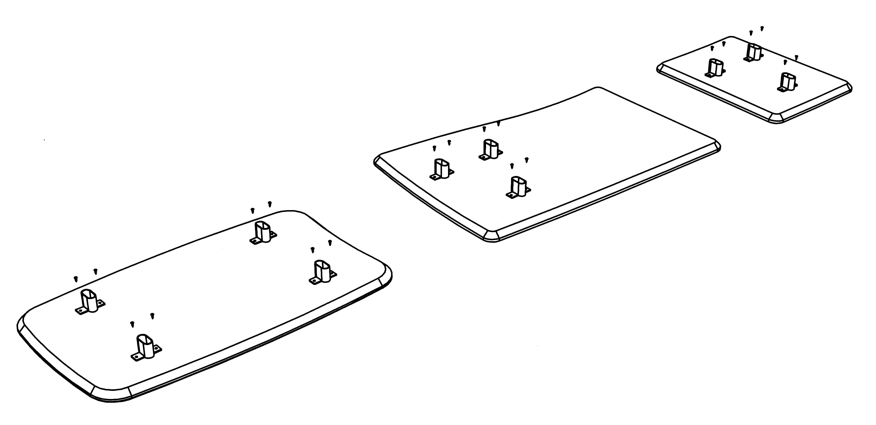
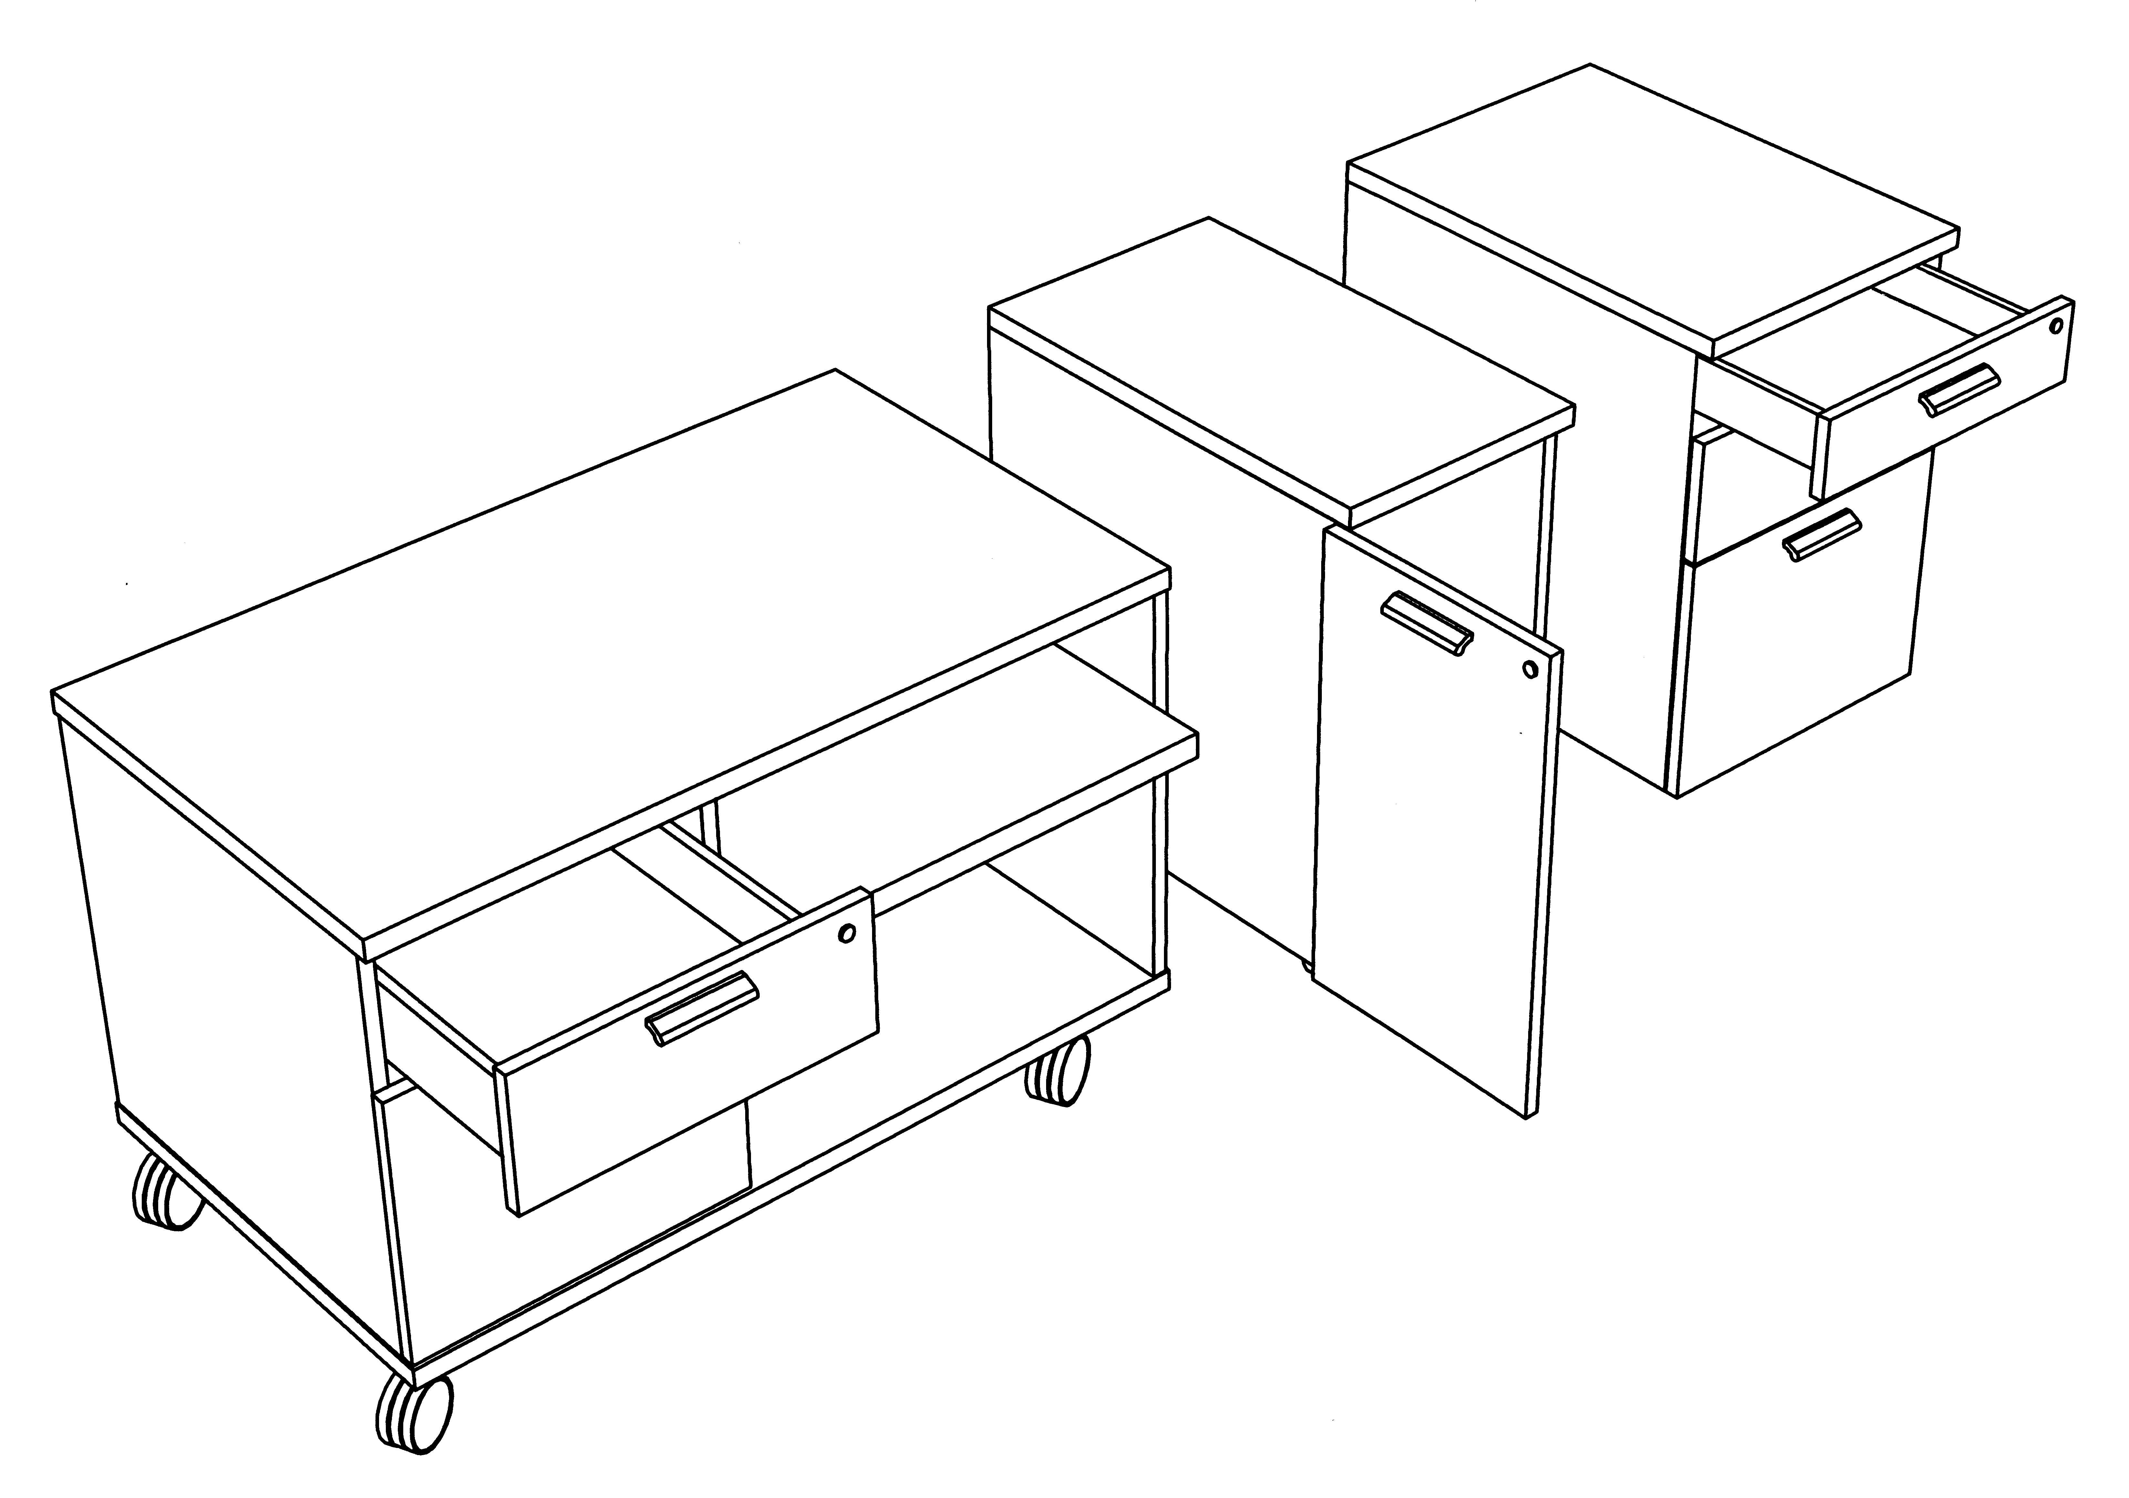
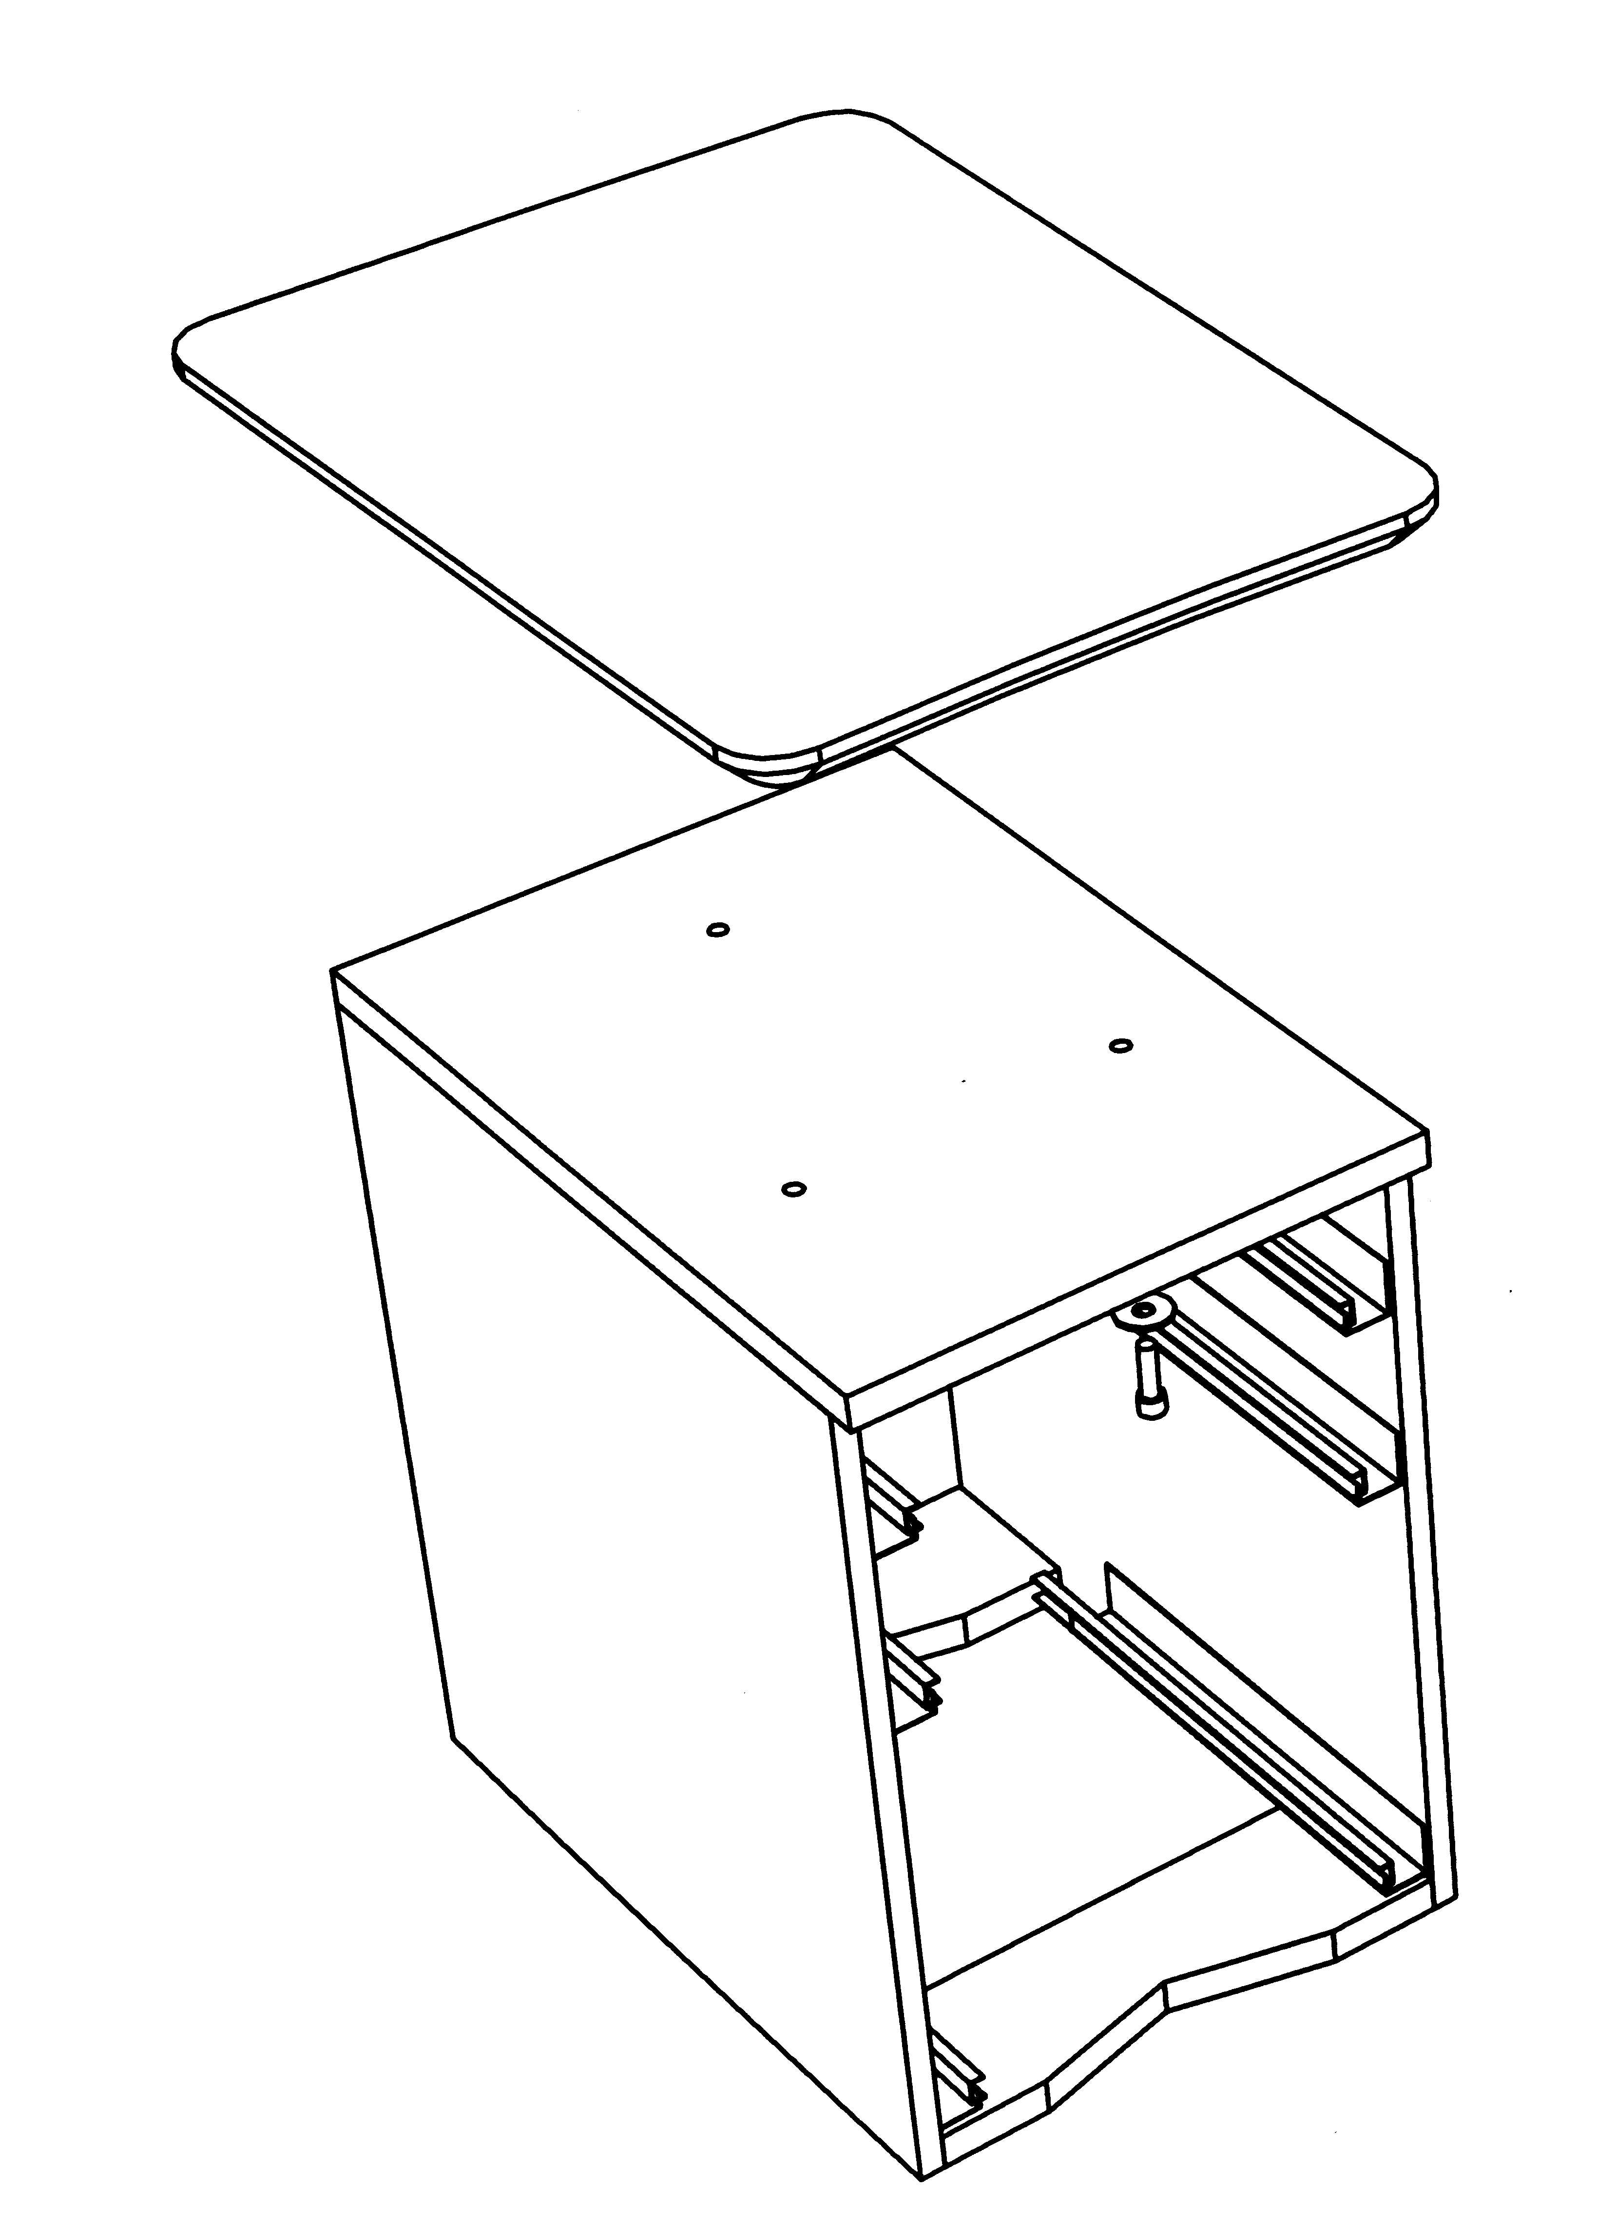
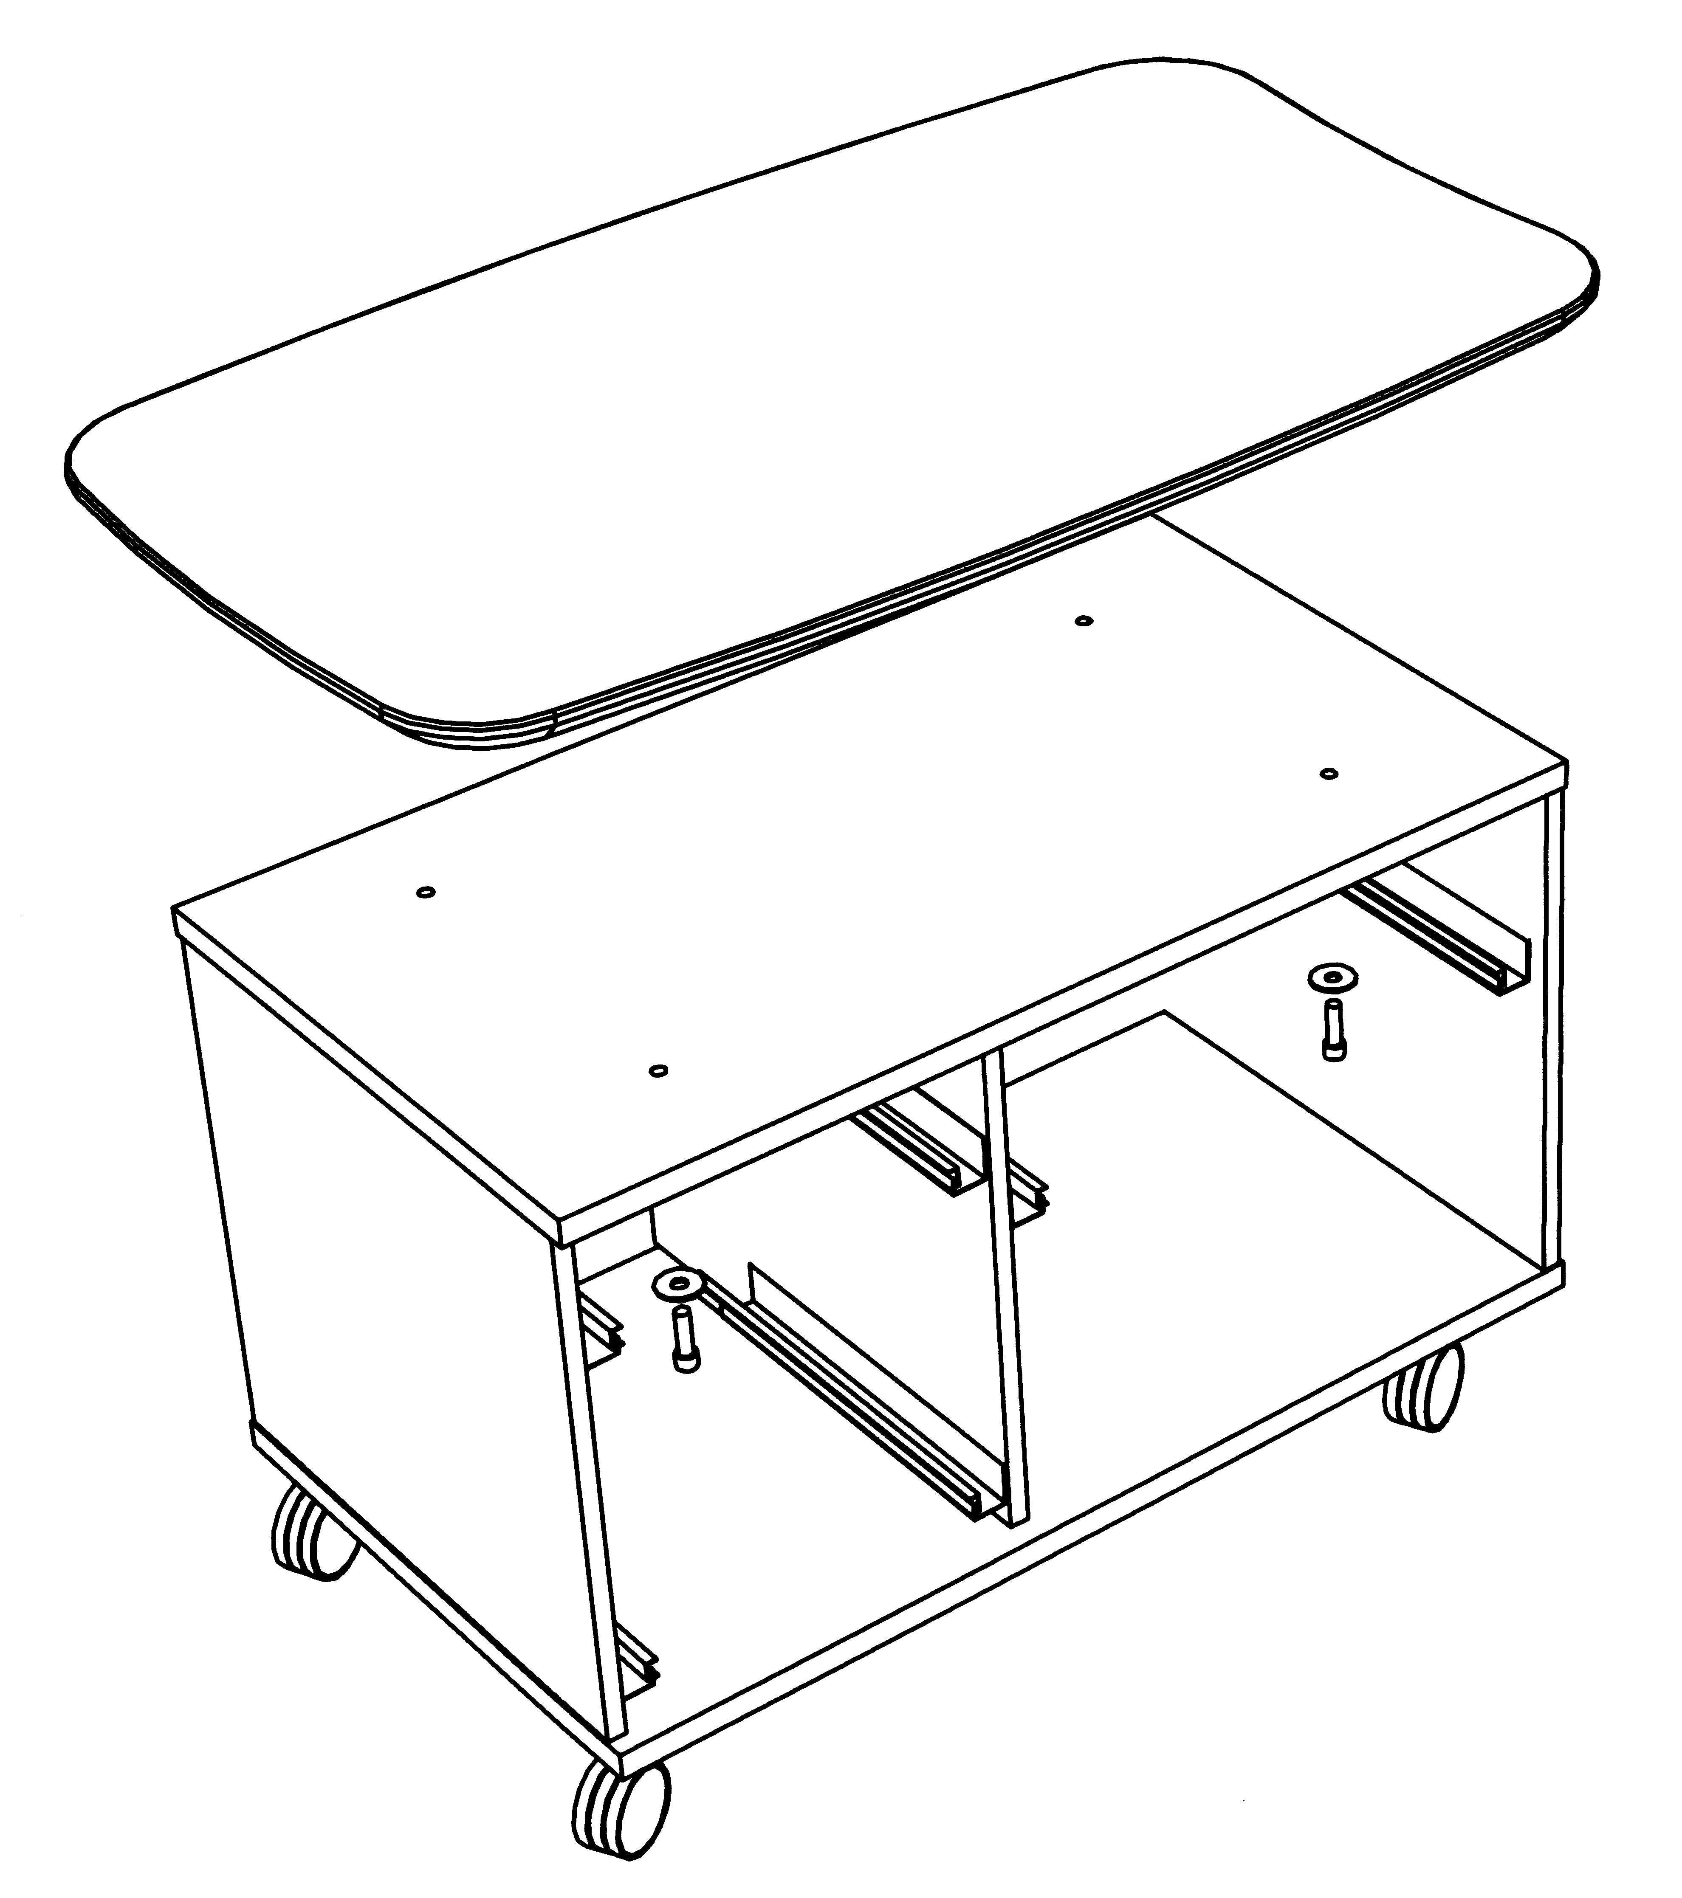
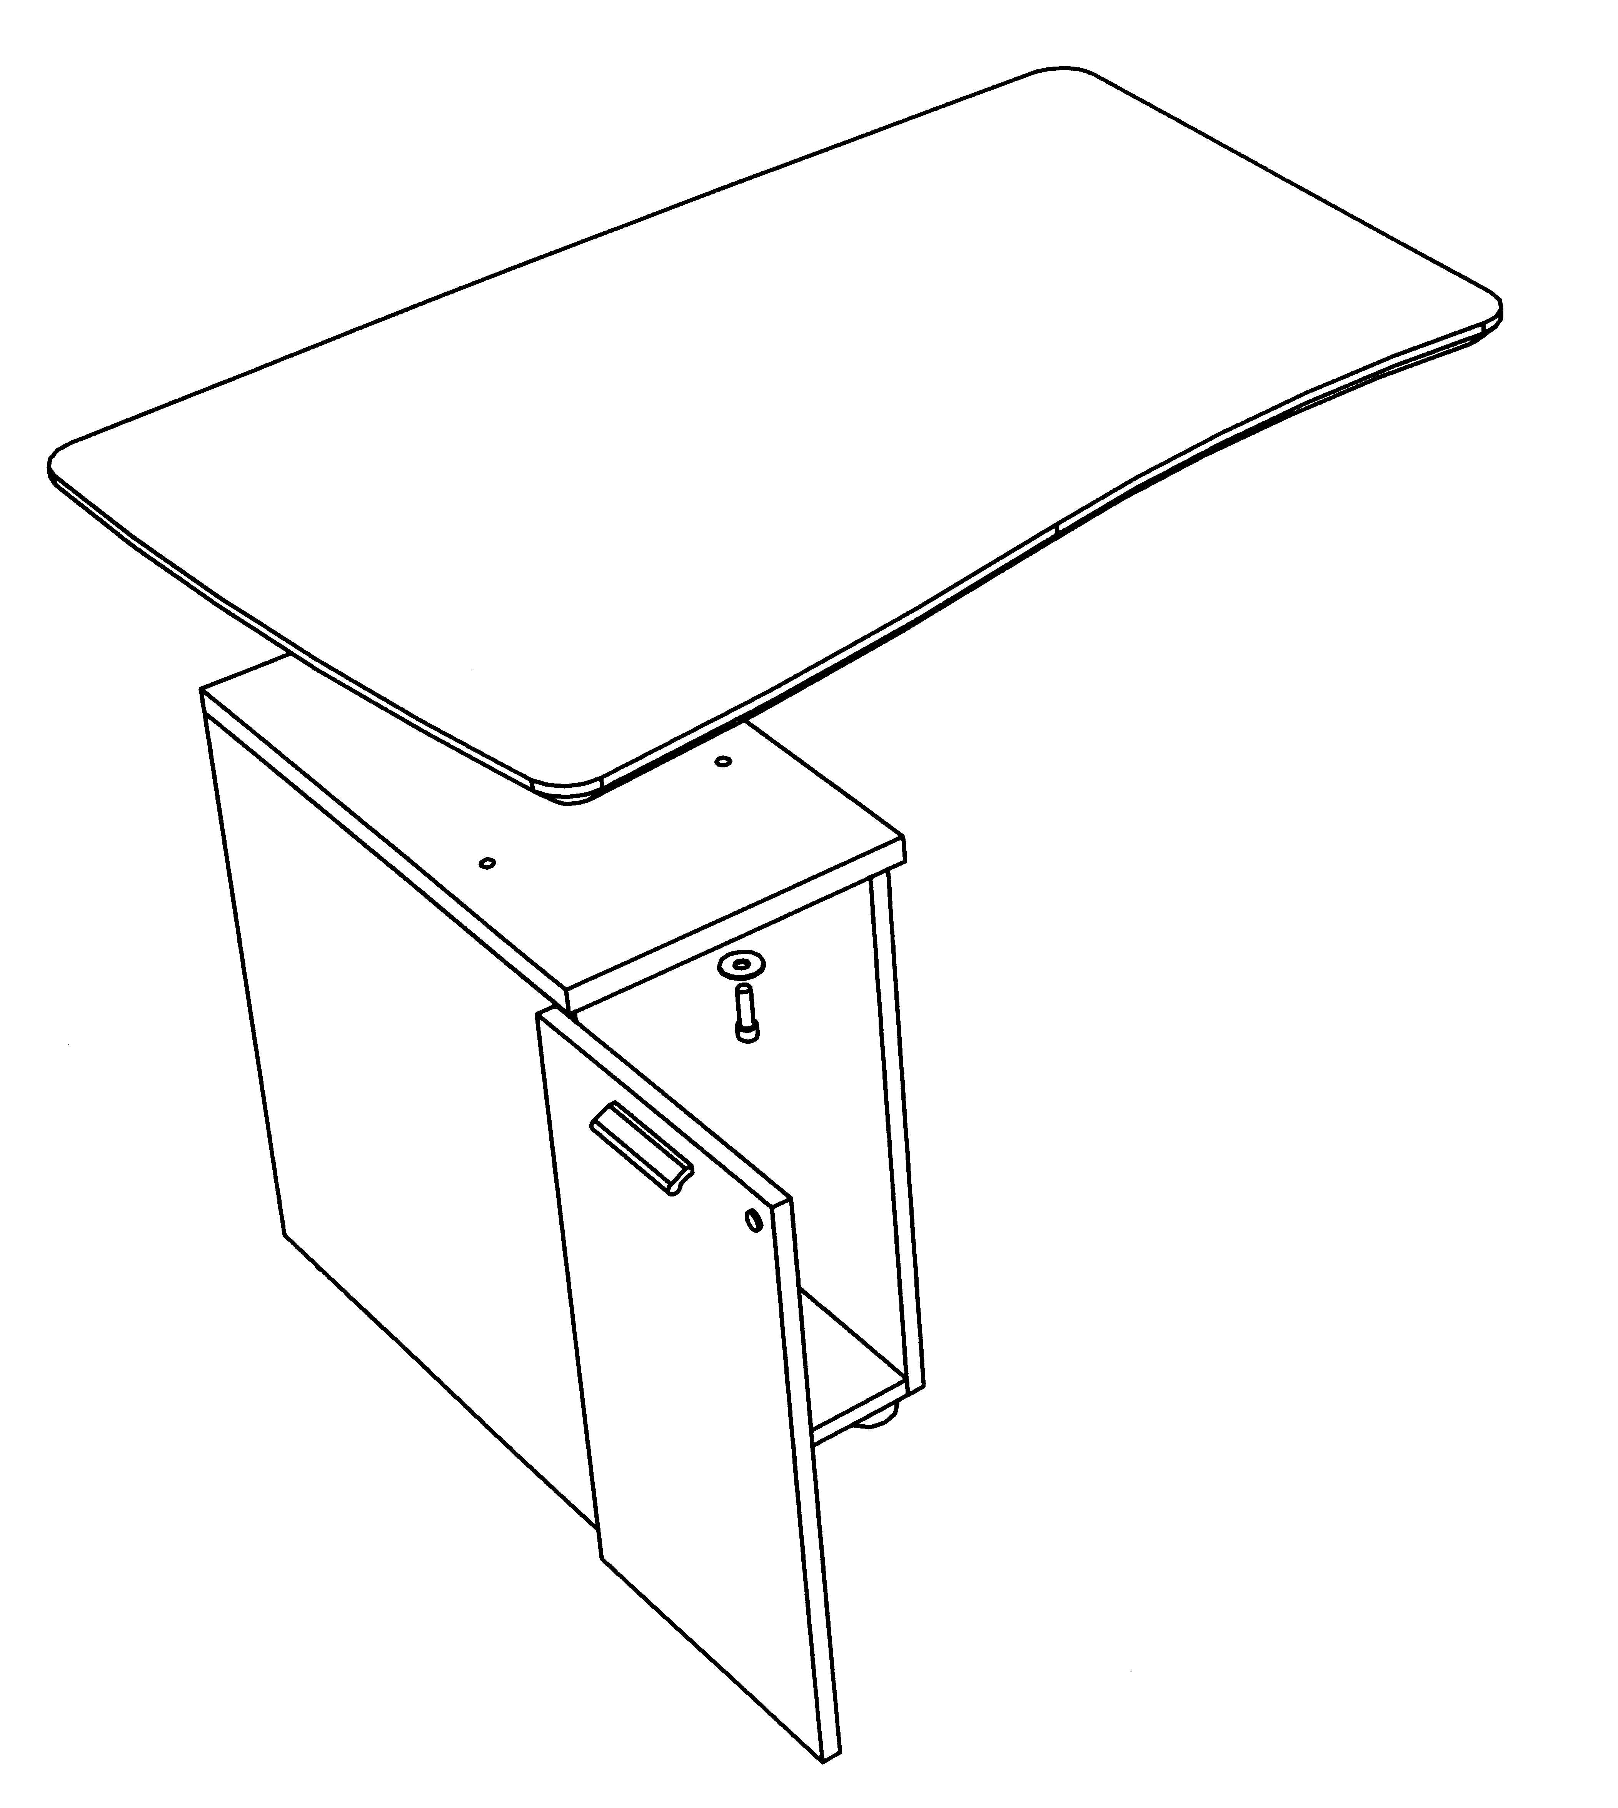
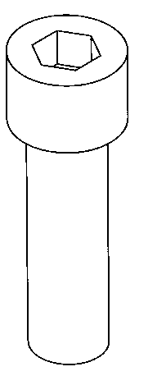
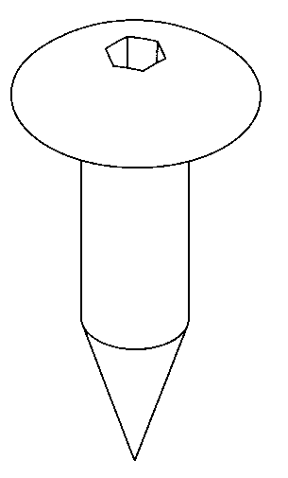
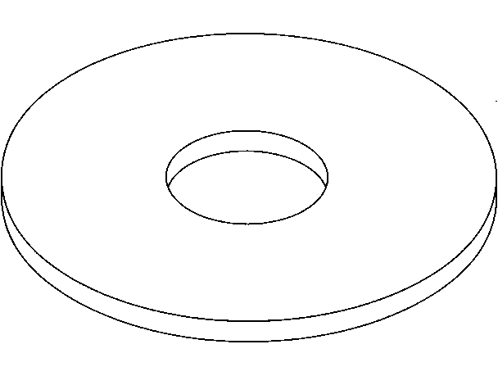
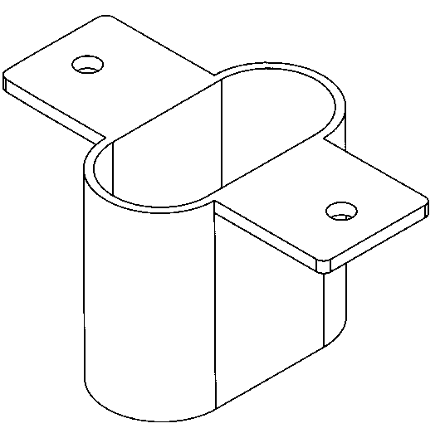
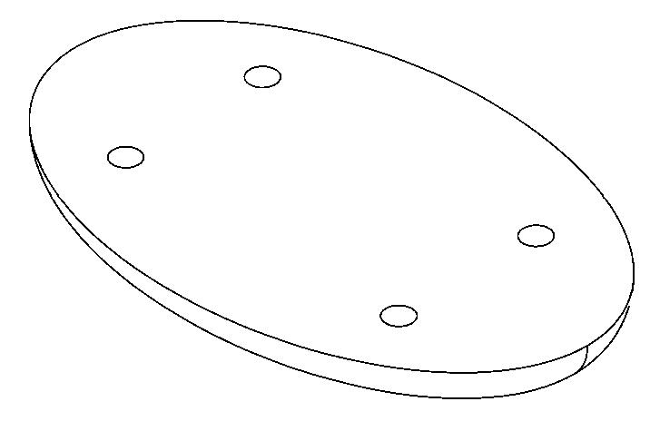

X 4
X 4
X 4

Intuition Floating returns assembly instructions

IKRT 1106. ICRT1107. IMPT0506. IRT/FP
STEP 2.
Align metal spacers with holes in tops and fix in position using the mushroom headed screws provided.
STEP 1.
- Undo small runner screws on underside edges of drawers (retain screws).
- Lift drawers/shelf up and pull to remove.
- Drill out part bored holes in underside of top (Use
13mm diameter drill.
STEP 4.
Fix tops to cabinets using the M12 x 35 button socket cap screws and large washers provided.
1/5/2004 SHEET 4

X 16
FITTINGS

X 2
STEP 3.
Fix linking plates to underside of return top (crescent or kidney) using the mushroom headed screws provided.
STEP 5.
Replace all drawers/shelf
following step 1 in reverse.
STEP 6.
Fix linking plates on return top (crescent or kidney) to underside of desk top using the mushroom headed screws provided.

