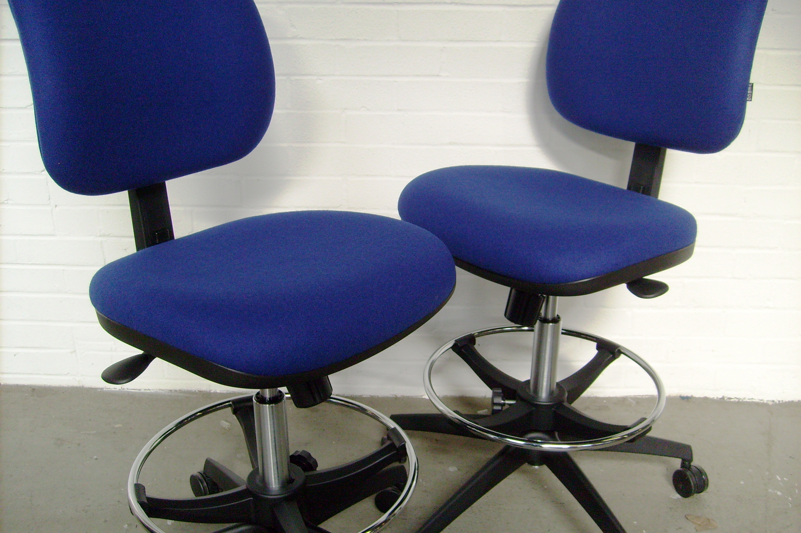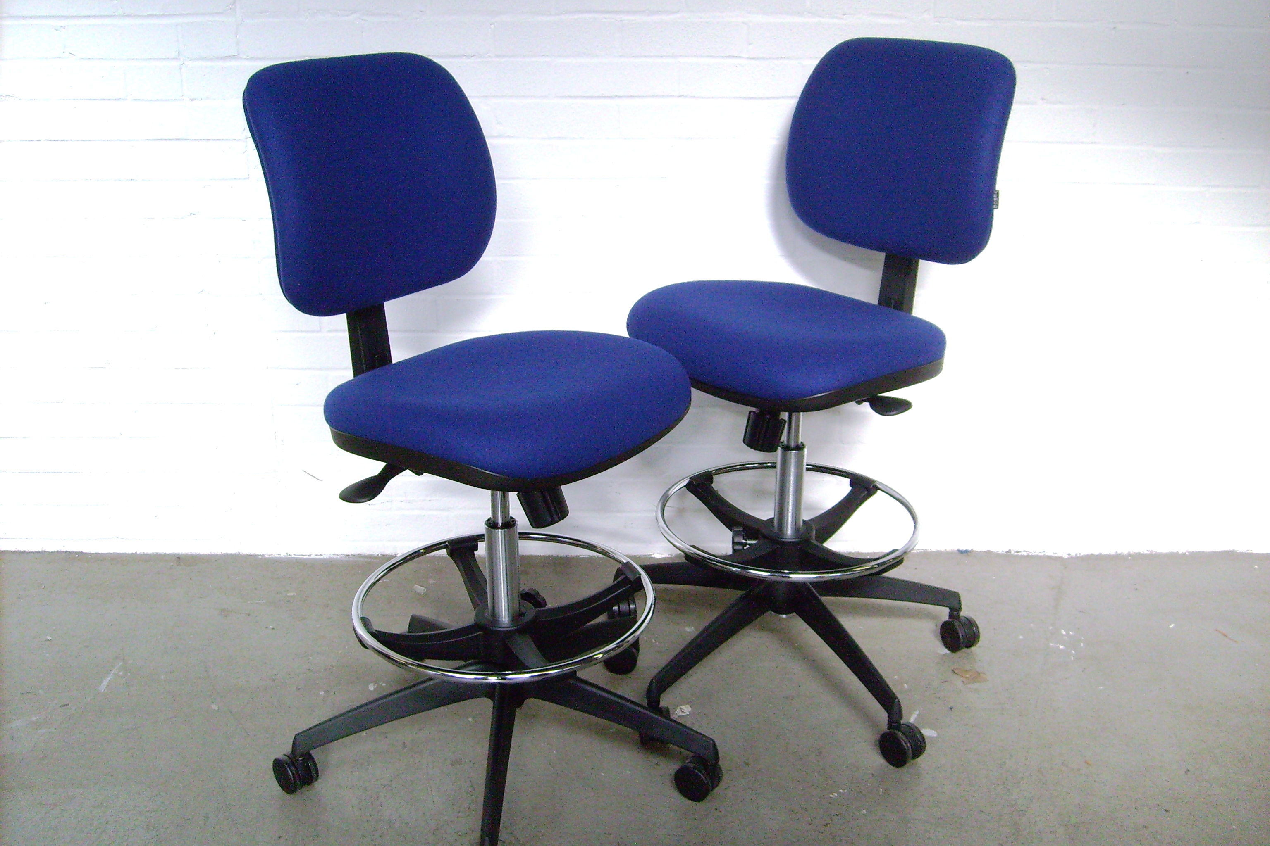
BARCLAYS BANK PLC

Branch Seating Operating Instructions

Teller Chair- VERCO BAR 294T
Low Teller Chair - VERCO BAR 294TL
Back Height Adjustment
To increase back height, push button on inside of back rest,
raise or lower to desired position and release button.
Seat Height Adjustment
Lift the lever to start, use body weight to lower and ease body weight to raise.
Release lever to lock at desired height.
Footring
To adjust footring, loosen handwheel, re-position and re-tighten.
Back Angle Adjustment
Push lever DOWN to release back from locked position. Adjust angle to suit and release to lock.
Tension Control
To reduce the seat/back adjustment tension, turn knob anti-clockwise. To increase tension, turn knob clockwise.

