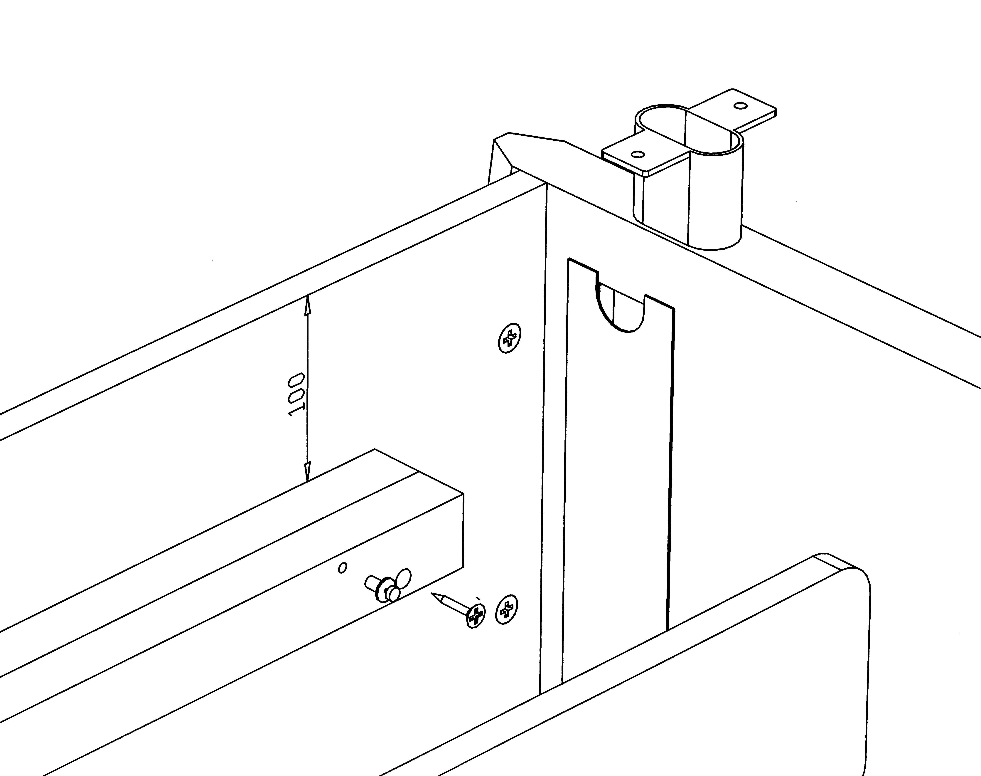
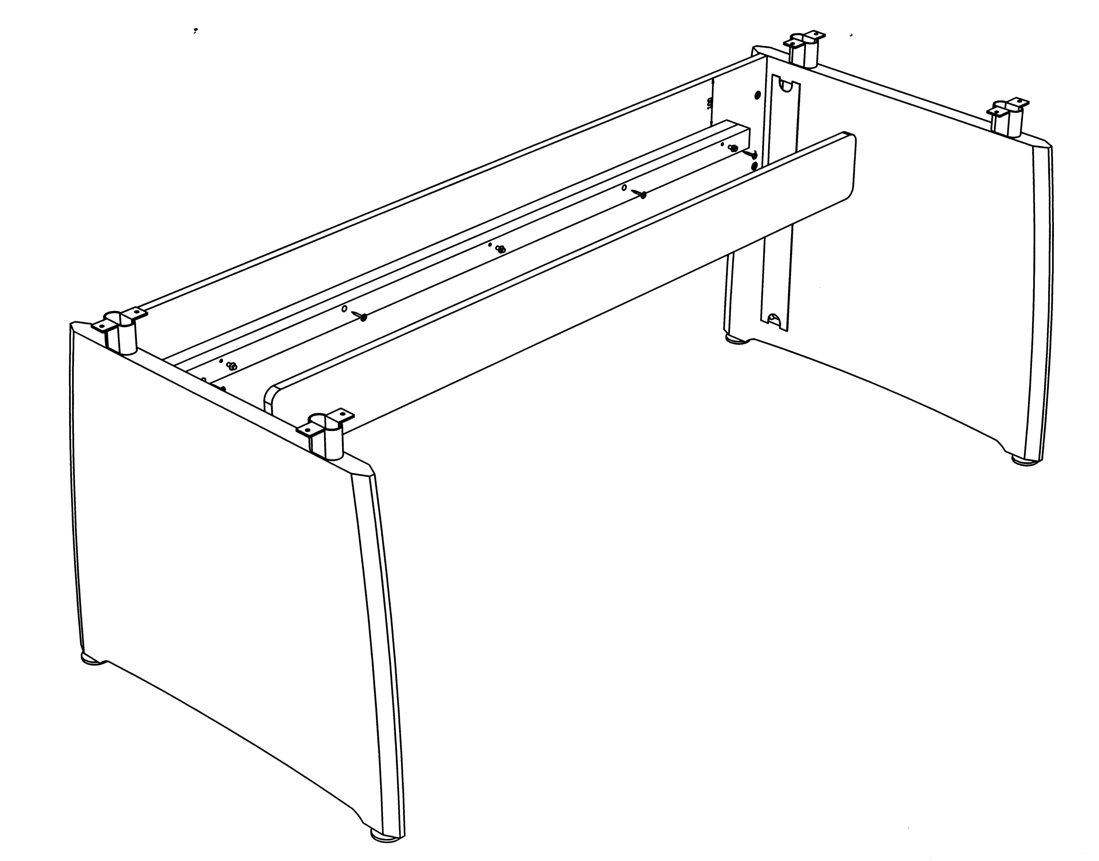

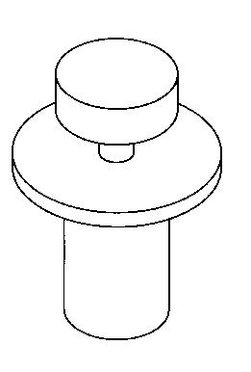
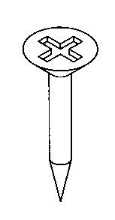

Intuition
Special wire management tray assembly instructions
STEP 2.
SCREW BLACK SPACER RAIL TO INSIDE FACE OF BACK PANEL 100mm FROM TOP EDGE, ALIGNED CENTRALLY SIDE TO SIDE. SEE IMPORTANT NOTE
STEP 1.
SCREW 3 OFF FLANGED KEY HOLE SCREWS INTO BLACK SPACER RAIL.

STEP 4.
FRONT VENEERED PANEL WILL DROP ONTO KEY HOLE SCREWS. LIFT OFF FOR ACCESS.
FITTINGS

X 3

(KEYHOLE SCREWS)

X 4

(4 X 45 CSK SCREWS)

IMPORTANT:

MAKE SURE PANEL IS MOUNTED SO THAT KEY HOLE SCREWS ARE AT TOP OF BLACK PANEL AS PER DIAGRAM.

REAR OF BLACK SPACER WILL HAVE SCREW HEADS SHOWING

