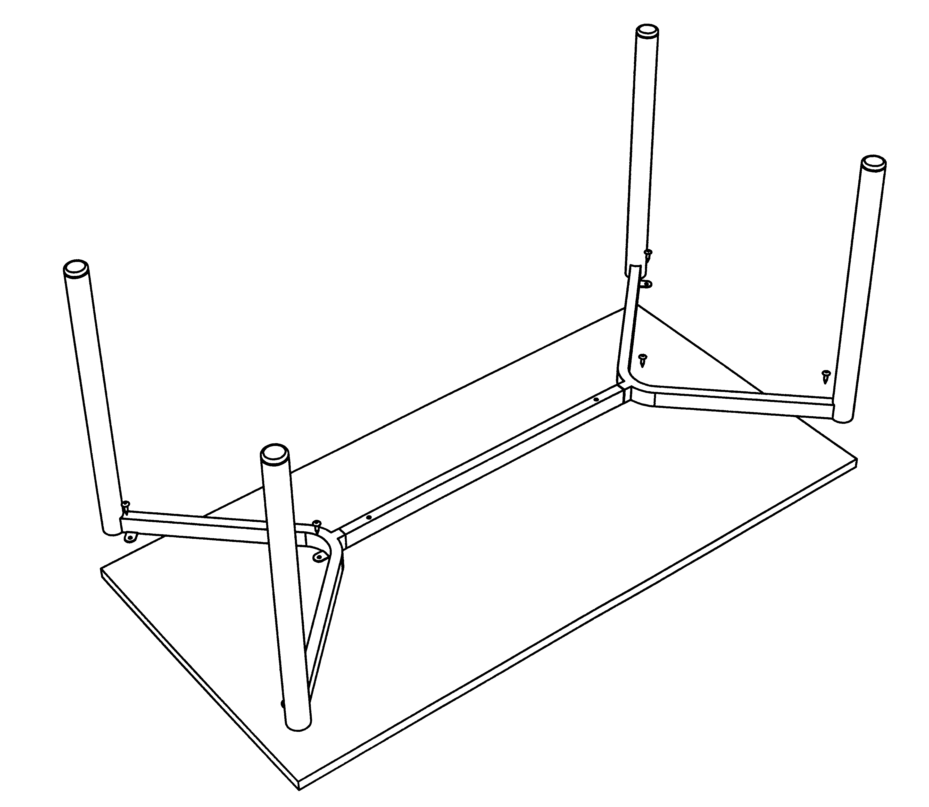
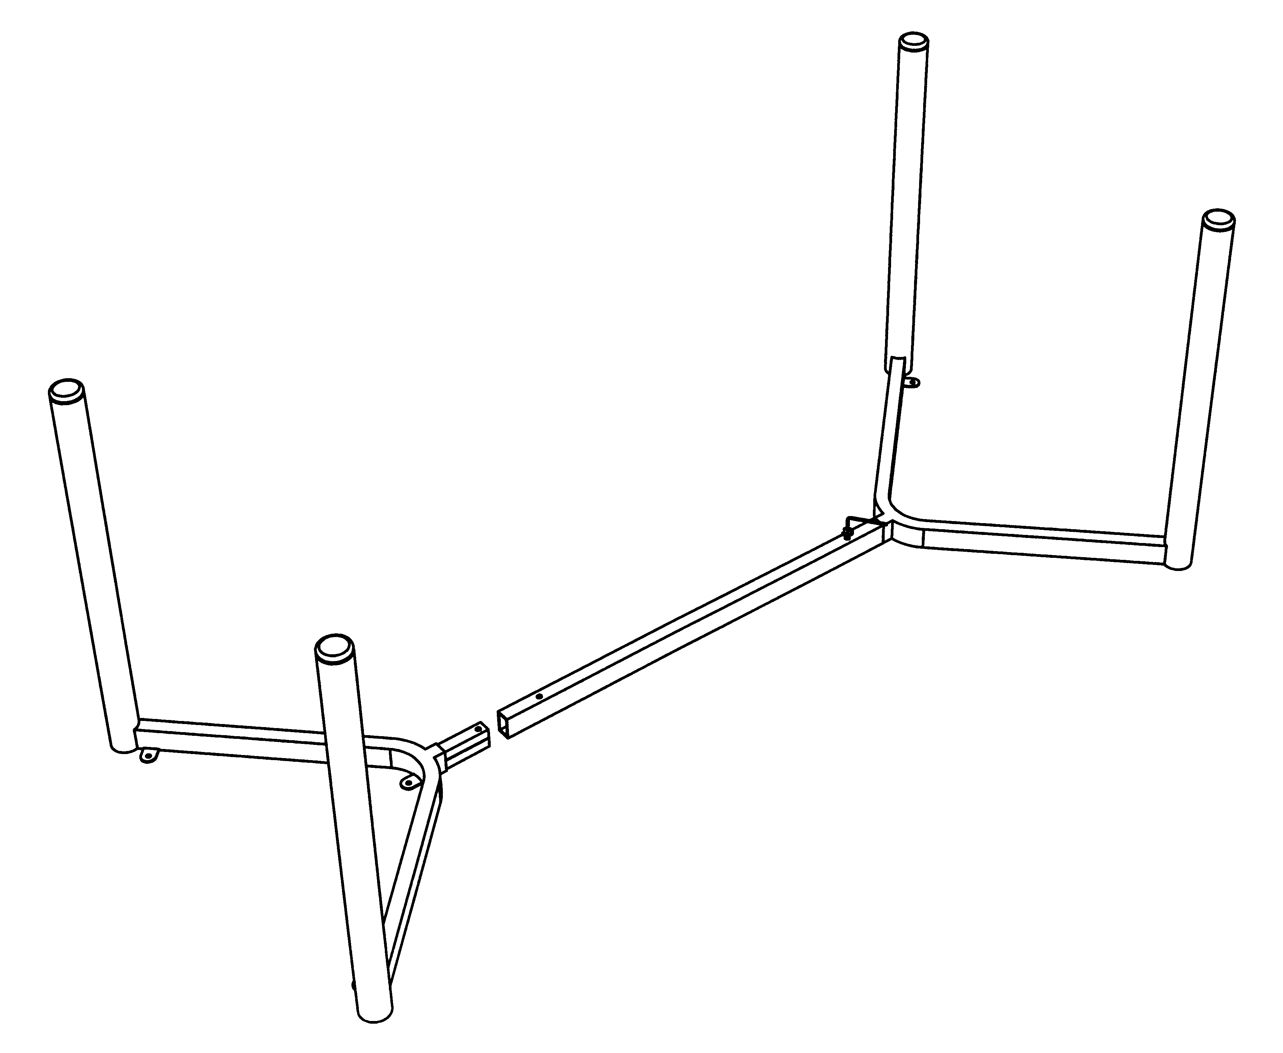
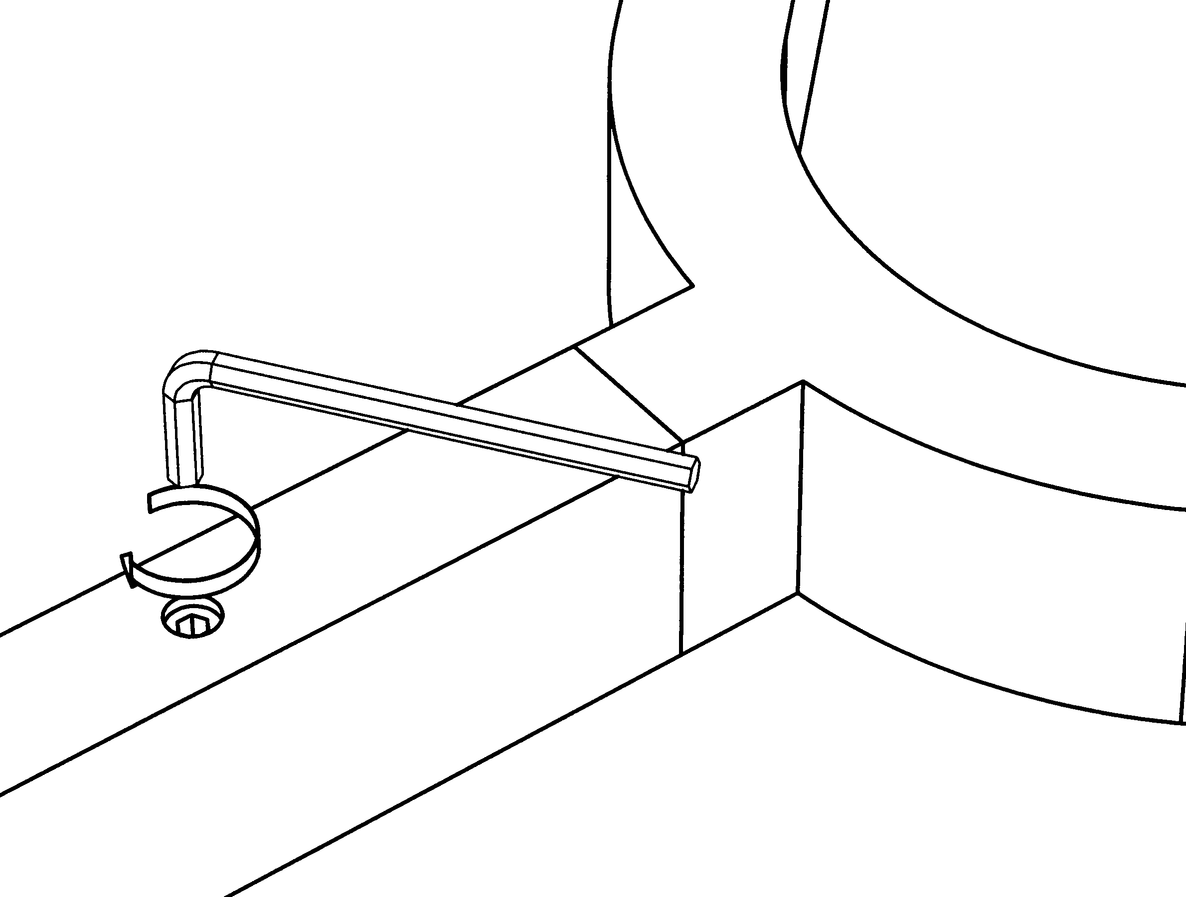
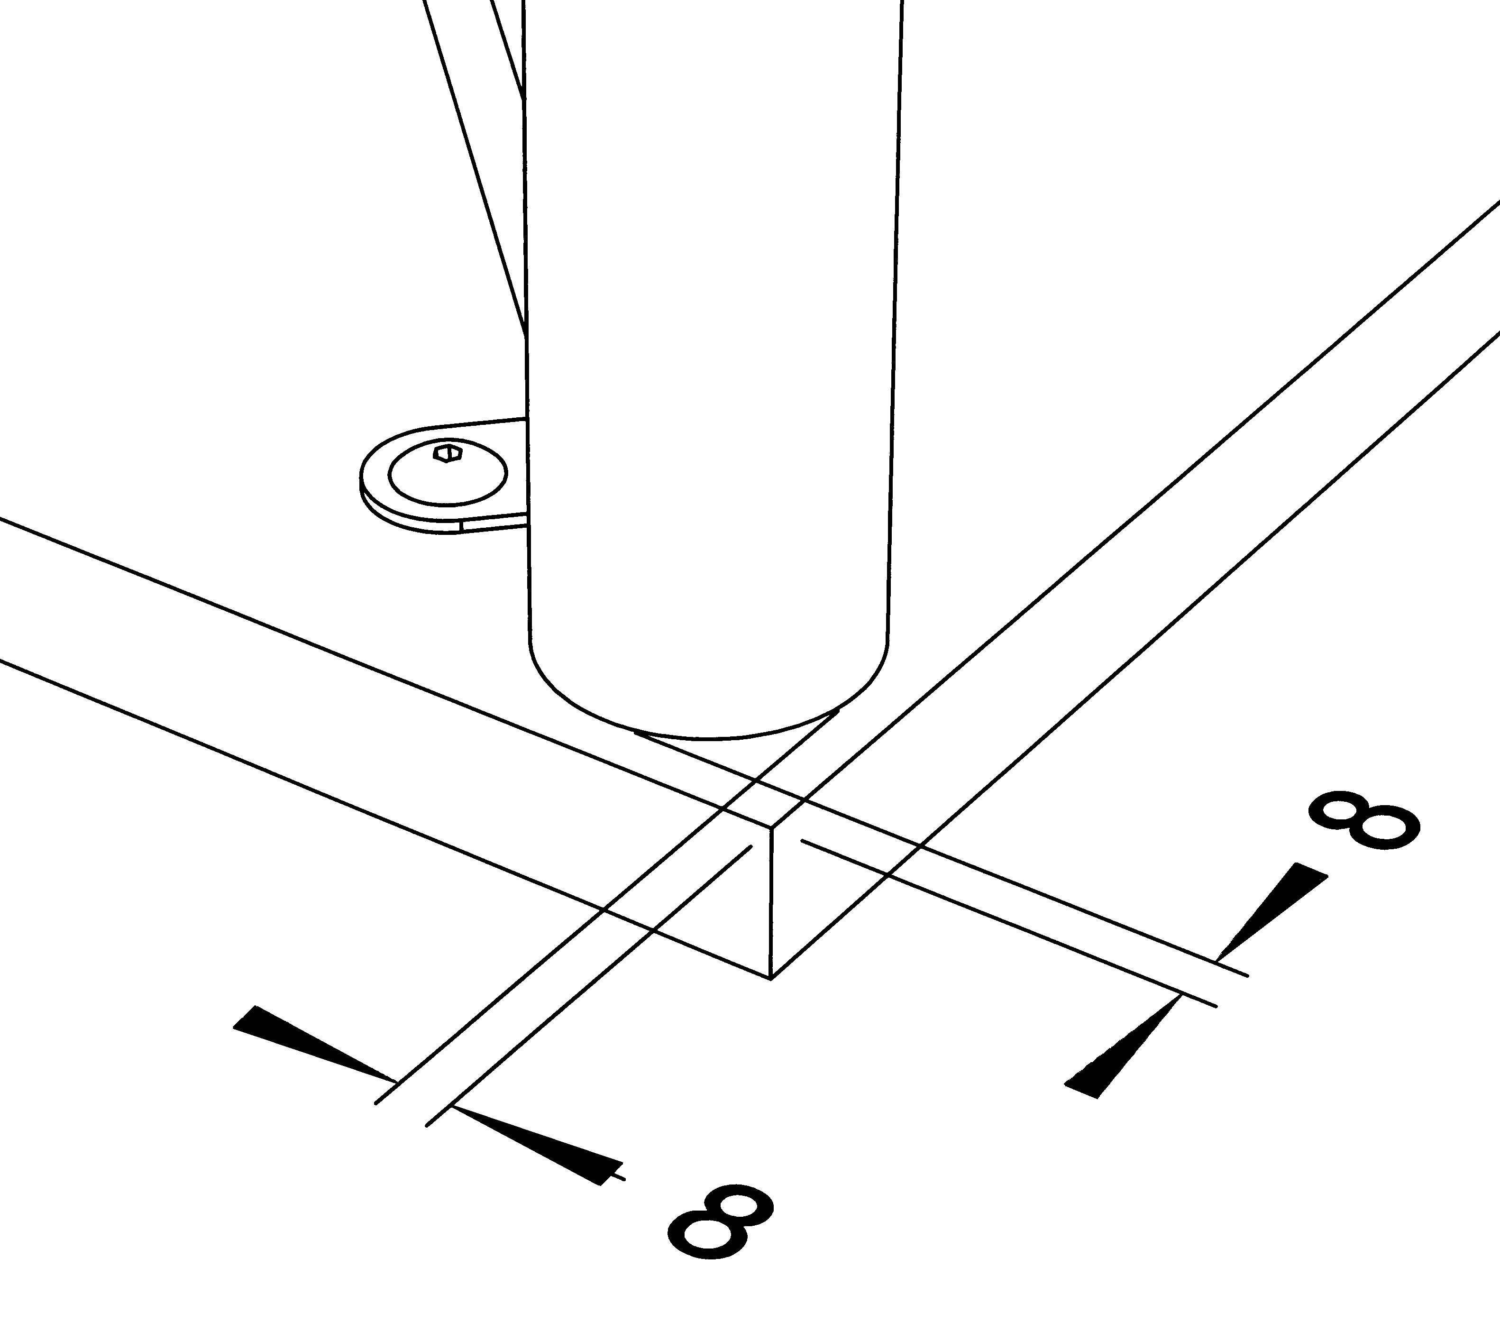
VISUAL Multi Purpose Tables
Assembly instructions
STEP 1.
- Slot end frames into cross rail.
- Holes in ends of rails should reveal fixing in end frame when slotted together.
- Tighten fixing with an allen key (Detail ‘A’).

Detail ‘A’
STEP 2.
- Align underframe on underside of top so that legs are approximately 8mm from each edge (Detail ‘B’).
- Screw assembled underframe to desk top using 6 screws provided.

Detail ‘B’

